KV6002

Terms of Reference

Neetan Briah (W16028251)

Jordan Delaney (W16015149)

Lee Haley (W16014111)

Aows Rashad (W16024005)

Umar Shaban (W16015928)

Table of Contents

The Vision of the Project 4

Roles 6

Team system specification – Requirement capture and analysis 7

Survey 7

Questions and feedback 7

Features 14

Specification of main functional subcomponents 15

Requirements specification for common elements 15

Team system specification 15

Stakeholder questionnaire 15

Relevant systems 16

The legal, social, ethical and professional dimension 19

Introduction 19

Legal Aspects 19

Data protection 19

Copyright 19

Social and Ethical Issues 20

Professional Dimensions 22

References 22

The Project Tasks and Deliverables 24

Agreed Deliverables 24

Usability 24

Code of Conduct 24

Quality Control 24

Meetings 25

Group Work 25

Resources List 26

Testing procedures/strategy 27

Black box testing 27

Decision Tables 27

Unit Testing 28

Integration Testing 28

References 29

Risk Analysis 30

Gantt Chart 32

Costing 34

Importance of cost estimation 34

Project cost techniques 34

The Estimation 35

Direct Costs 36

Domain and hosting cost 40

Conclusion for Project Costing 40

References 41

Subcomponent Specification 42

Neetan Briah (W16028251) 42

Scope Subsystem 1 42

Research 43

Jordan Delaney (W16015149) 45

Search Filtering and Customisation 45

Lee Haley (W16014111) 47

Introduction 47

Stakeholder input 47

Predicted look for system 48

References 48

Aows Rashad (W16024005) 49

Introduction 49

Umar Shaban (W16015928) 52

Requirements Capture Plan 52

Requirements Specification List 57

# The Vision of the Project

|  |  |  |
| --- | --- | --- |
| Group Member Name | | Programme |
| Neetan Briah (W16028251) | | Computer Science |
| Aows Rashad (W16024005) | | Computer Science with Web Development |
| Lee Haley (W16014111) | | Computer Science with Web Development |
| Jordan Delaney (W16015149) | | Computer Science with Web Development |
|  | |  |
| Project Idea (One sentence) | | |
| Produce an online web-based system for travellers. | | |
| Explanation (one paragraph) | | |
| The ultimate travellers home. Creating a customised online web-based interactive system, which provides an environment for travellers to post about their travel locations, review travel locations whilst also supporting the arrangement of future travels (either buddying up or as part of a larger group) and social events. | | |
| Group Work | * The system must be demonstrated via cloud platform. * The system must follow a common look and feel that will be designed with accessibility in mind. * The system must be secure. * Users must be appropriately authenticated. * Different user types must be authorised to perform different roles within the system. * Appropriate fields in the underpinning database must be encrypted. * The system must support one of the browsers installed on a university desktop. * The system could support multiple browsers. * The system should support access by devices with different screen sizes. | |
| Subsystem 1 | Administration/Users  A web-based interactive application which:   1. Must allow different levels of user (standard member/organising committee member/admin) with different permissions. 2. Must enable user registration and membership (i.e. registration/type of membership) to be confirmed. 3. Must allow the management of passwords/password resets. 4. Should allow the suspension and deletion of registered user accounts. 5. Could allow an organising committee member to send an email to all currently registered members and just organising committee members. | |

|  |  |
| --- | --- |
| Subsystem 2 | Travel Rating and Recommendation  A web-based interactive system which:   1. Must allow all registered members to suggest/recommend travel spots (i.e. create, edit, delete travel suggestions based on text graphical representations). 2. Must enable other registered members to rate a suggested travel spot. 3. Must enable other registered members to leave reviews (i.e. comment on) a suggested spot. 4. Should allow an organising committee member to suspend, edit or delete a suggest spot or review. 5. Could allow a registered member to report/flag concerns over inappropriate content in a suggested spot or review. |
| Subsystem 3 | Create an Event  A web-based interactive system which:   1. Must allow all registered members to create, edit, delete and archive a event 2. Must allow all registered members to sign up to and/or cancel their place on an event. 3. Should allow comments to be made on an event page by those registered members signed up to attend. 4. Could provide a calendar view of events. |
| Subsystem 4 | Discussion board/forum  A web-based interactive system which:   1. Must only allow organising committee members to create and view threads (topics) for discussion. 2. Must allow only registered members to view and post messages. 3. Must allow responses by registered members (giving username and date of post). 4. Could provide registered users with a list of system generated recommendations based on their habits or the similarities of other locations. |
| Subsystem 5 | Search, filtering and customisation  A web-based interactive system which:   1. Must allow only registered members to search by keyword across all categories (i.e. spots, events and registered users). 2. Must allow only registered members to search events by type, date, duration, etc. 3. Must allow only registered members to filter spots by distance, rating, etc. 4. Should allow only registered members to customise their profile pages/visible information. 5. Could include recommendations across all categories (e.g. potentially relevant alternatives) based on search criteria if no matching results are returned. |

# Roles

|  |  |  |
| --- | --- | --- |
|  | Mission / Role | Name |
|  | Group Work | **Group** |
|  | Administration/Users | Neetan Briah |
|  | Route Rating and Recommendation | Aows Rashad |
|  | Create an Event (Running or Social) | Umar Shaban |
|  | Discussion Board/Forum | Lee Haley |
|  | Search, Filtering and Customisation | Jordan Delaney |

# Team system specification – Requirement capture and analysis

## Survey

In order to capture the requirements for the project we conducted a survey of the stakeholders. The stakeholders for this project are people who like to travel, we surveyed 31 people asking questions in an attempt to find the features that people would want out of this website.

## Questions and feedback

1. **How often do you like to travel?** 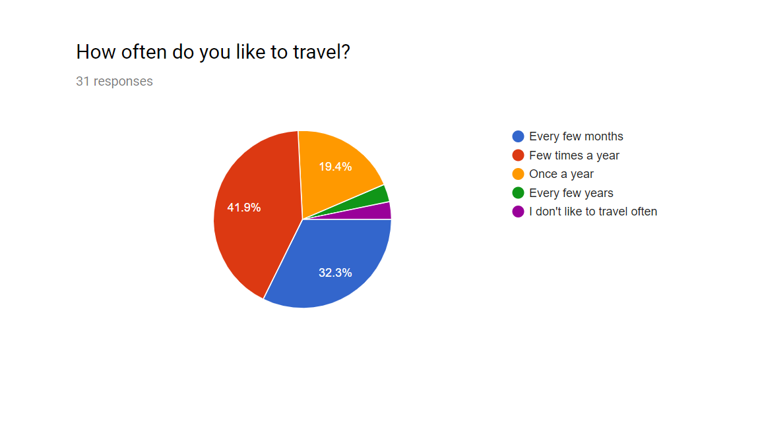

This question was mostly to get a gauge on the people surveyed, as can be seen from the feedback above almost all of the people we surveyed could be classed as quite frequent travellers.

1. **Do you like to take pictures when you travel?** 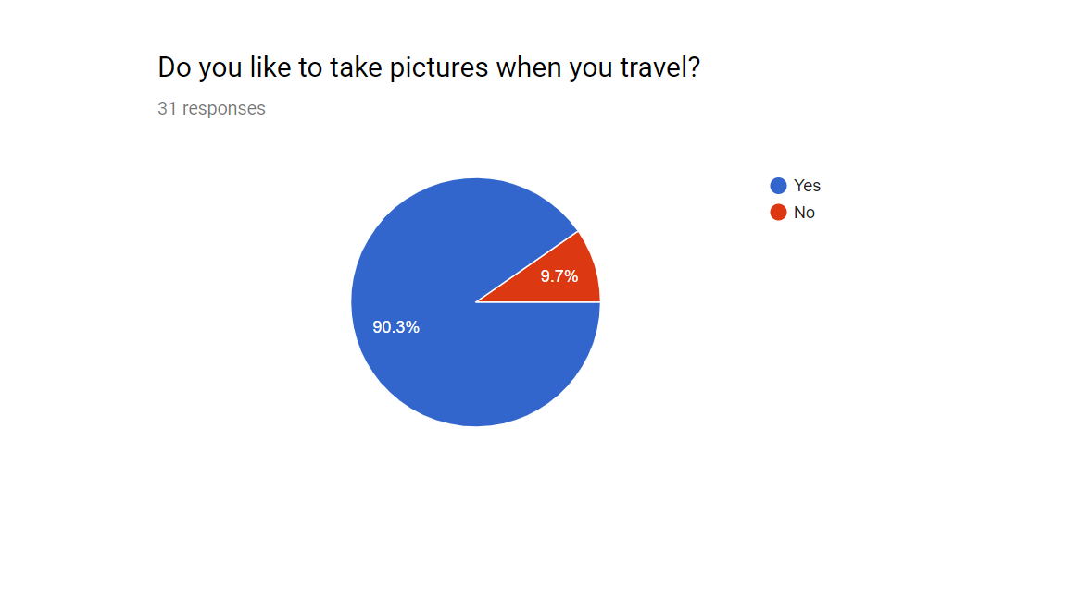

We wanted the sharing of pictures to be a large part of the website, however for this to be a viable feature we needed to see what percentage of people enjoy taking pictures when they travel

As can be seen from the results above the overwhelming majority of those survyed regularly take pictures when they travel.

1. **If yes do you share the pictures you take on social media?** 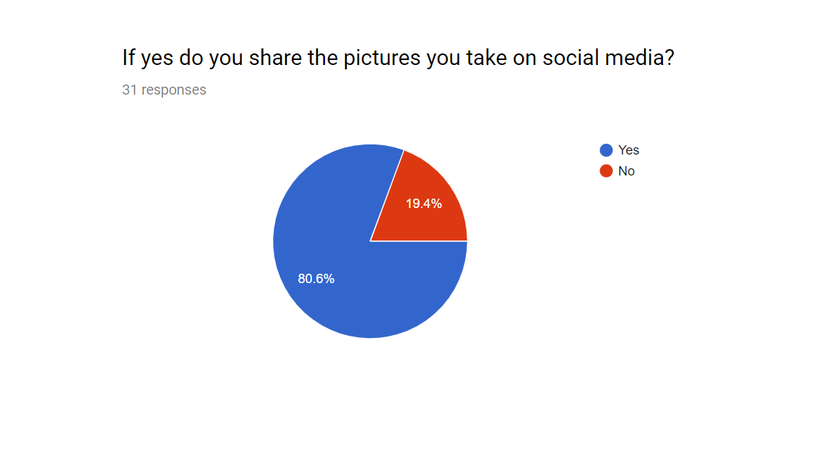

The second part to this question was if the users then shared those pictures onto social media. This is very important because we needed to eastablish that people would be willing to share there photos on our site.

The feedback shows that not everyone who takes pictures while on holiday will then post those pictures to social media. However a good majority still do, we belive that this shows that users would be willing to share there travel photos on our site.

1. **Do you look at other people’s travel posts (pictures, status updates etc) on social media?**

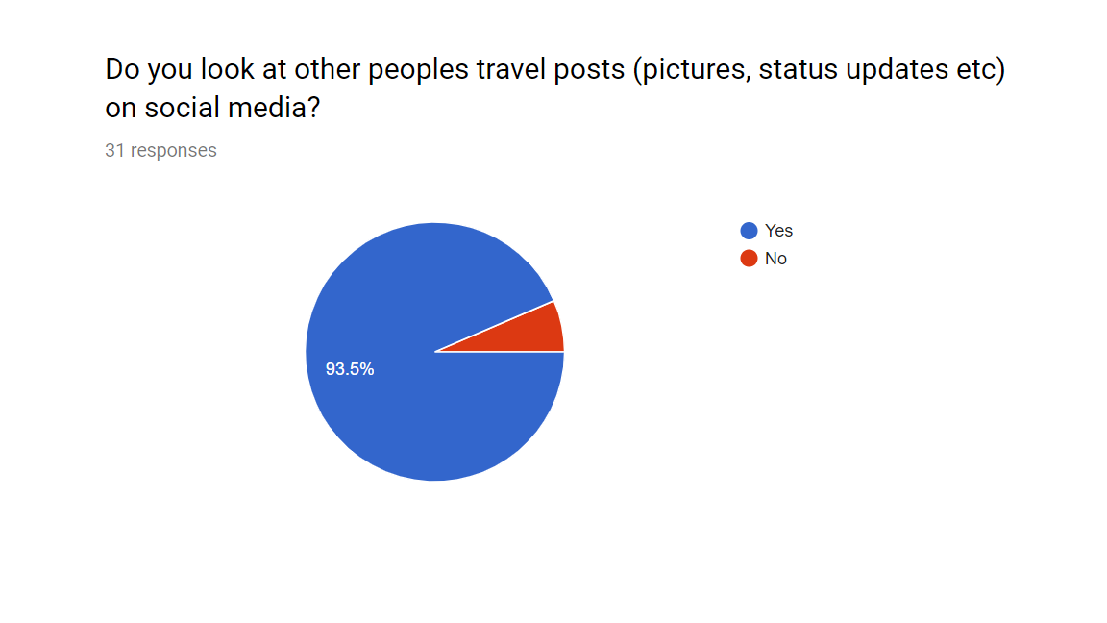

Building on from the previous questions we needed the oppostie perspective, we needed to know if users actually looked at the trvael photos that were being uploaded onto social media. This was important for us as it would essetionally be the bases of our whole site that you come to look at photos and read about different locations that you may end up visiting.

The feedback shows that a large majority of those asked do look at other peoples travel related social media posts.

1. **If yes have you ever been inspired to travel somewhere due to one of these posts?**

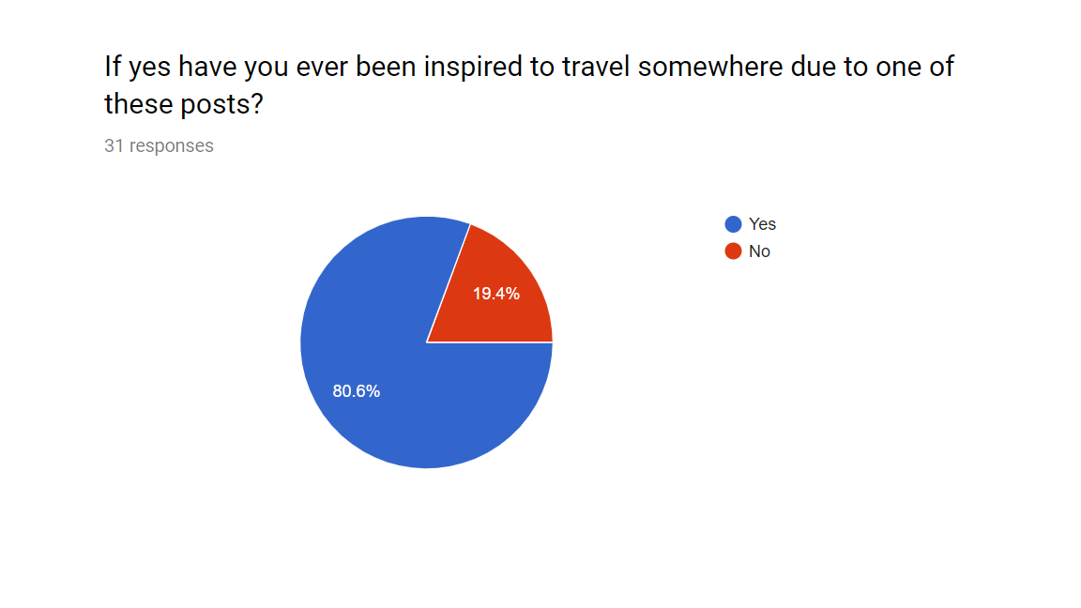

The second part to this question was if seeing these posts had ever inspired the participants to travel to somewhere do to seeing one of these social media posts. Again this is quite a critical question because if the majority answered no then it would essentially derail the entire idea behind the website.

Fortunately again the majority of those asked replied that they have been inspired to travel somewhere due to seeing a post on social media.

1. **Do you enjoy recommending travelling locations and hot-spots to your friends?**

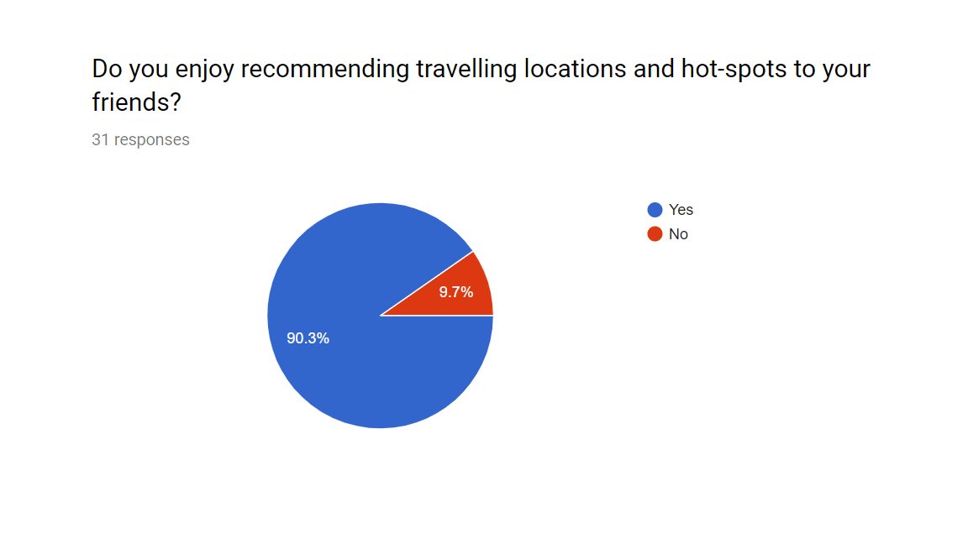

The next set of questions were to gauge how much users would want some sort of rating or feedback system for the posts they share to the website. This first question also links back to our previous questions also about sharing travel experiences.

Again the majority of those asked said that they enjoy sharing locations and different spots that they found on their travels to their friends.

1. **If yes do you enjoy getting feedback on these recommendations?** 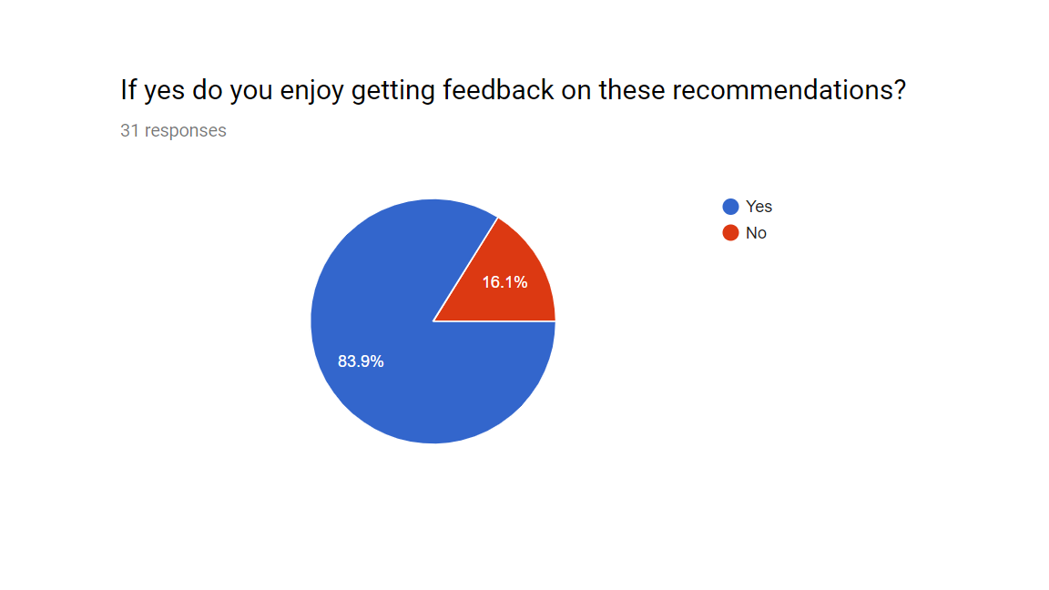

With this question we were trying to gauge how important a rating or some other sort of feedback system would be to the stakeholders. From the feedback that we gathered we can see that the majority of those asked would be interested in some sort of rating system.

1. **What sort of rating system do your normally trust?** 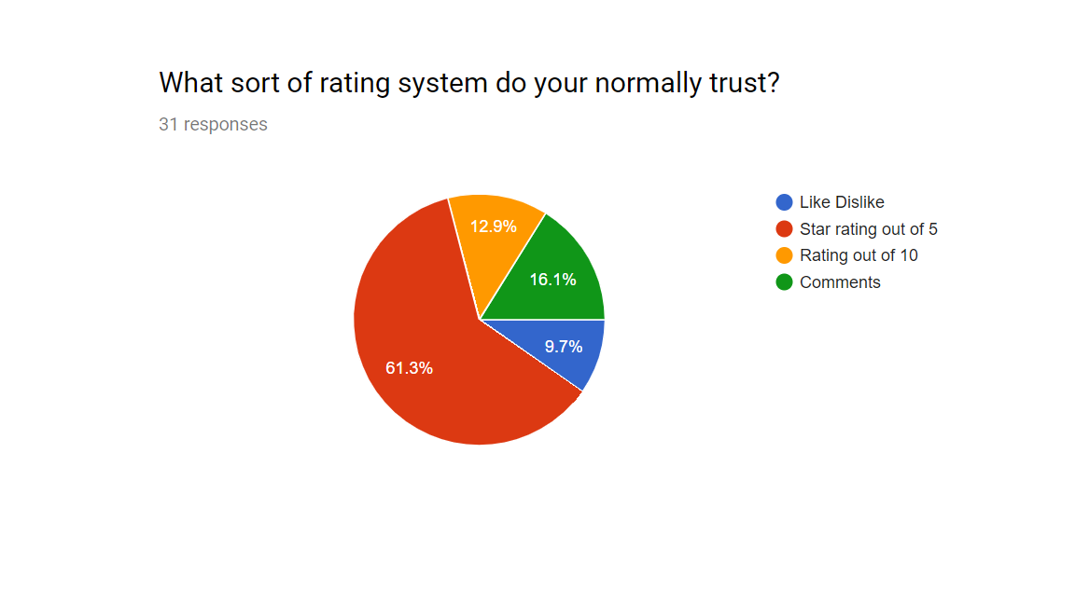

This question was to see what sort of rating system we would implement for the users posts onto the website. We came up with 4 different rating systems that we felt comfortable being able to implement into the site. From those the clear favourite was a rating out of five stars, comments also received a fair share of the votes.

From this we decided to go with a system where you would leave a star rating on user’s posts, as well as the option to leave a comment.

1. **Do you normally travel alone or with others?** 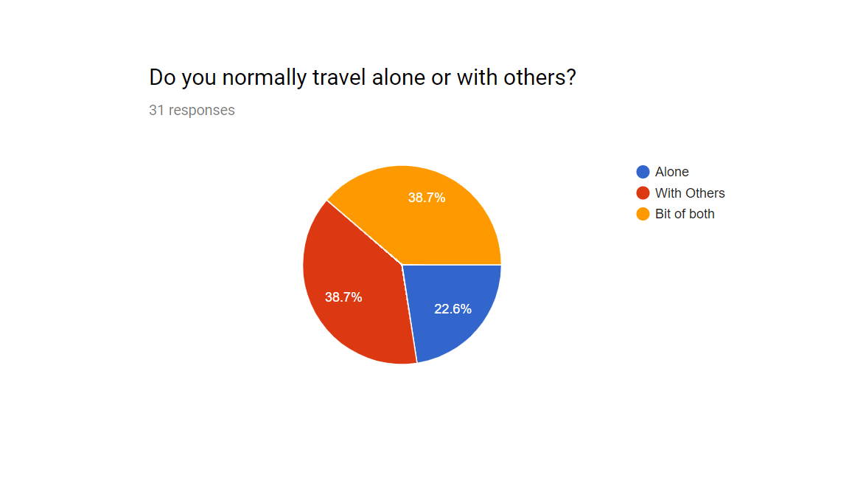

Our next questions were to try and judge weather people would like to use the site as an opportunity to meet travelling companions or to be able to organise events via the website. The first of these questions was to see how people normally travel, whether it is alone or with other people.

As can be seen in the feedback there is quite an even split, people who usually travel alone are in minority. Travelling with others or doing a bit of both were the much more popular answers. From this we can gather that those asked mostly travel in groups with a smaller minority travelling alone regularly.

1. **Do you like to meet new people when you travel?** 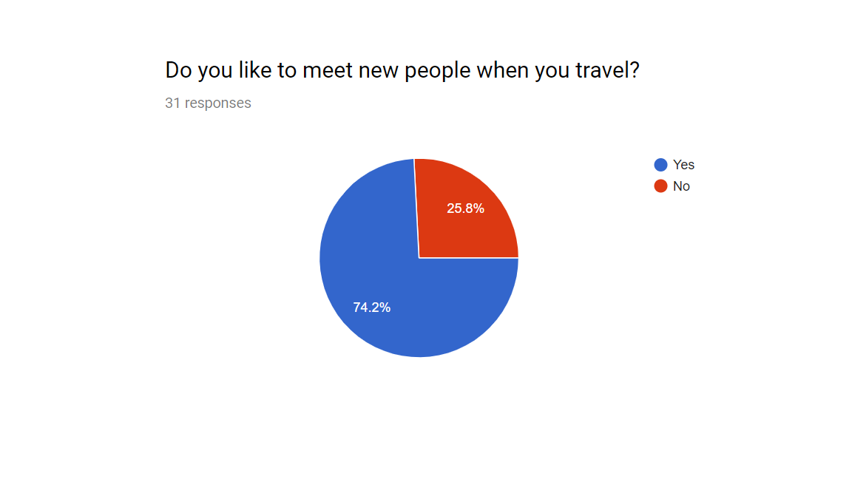

The next question was to establish if the participants enjoyed meeting new people when they travelled. We wanted this information because we reasoned that if the feedback showed that meeting new people while travelling wasn’t desired then the ability to meet people and create events though the website also would be a desired feature. From the feedback we can see that just less than three quarters of those surveyed do enjoy meeting new people while they travel. From this we can extrapolate that meeting people through the website and being able to setup meet-ups is something that the majority of users would participate in.

1. **Do you Enjoy talking to others about the places you have both visited?** 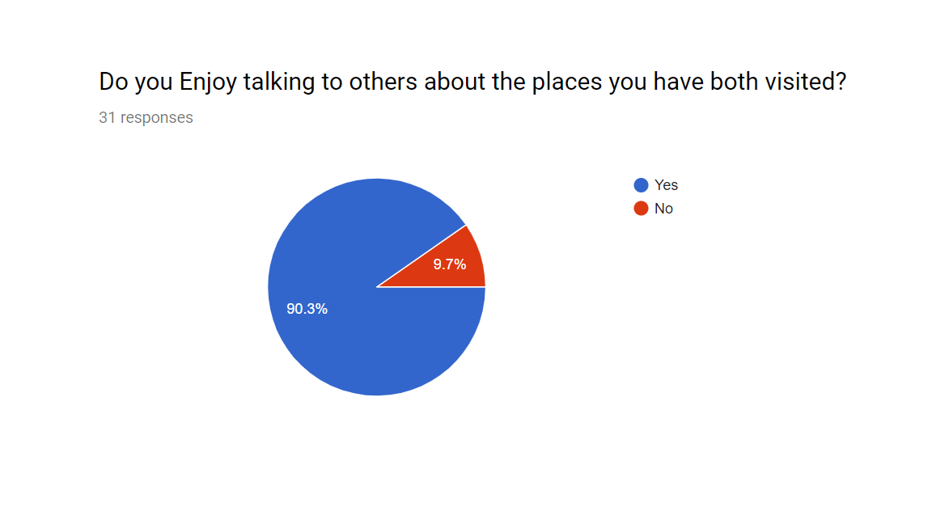

Next we wanted to find out if people would be interested in some sort of forum or discussion board on the website where they could talk about their travels and different locations they have been.

We expected this be a popular feature and we were proven right as just over 90% of those asked said they do enjoy talking about places they have both visited.

1. **Would you use a website that allowed you to share pictures and information about your travels with others?** 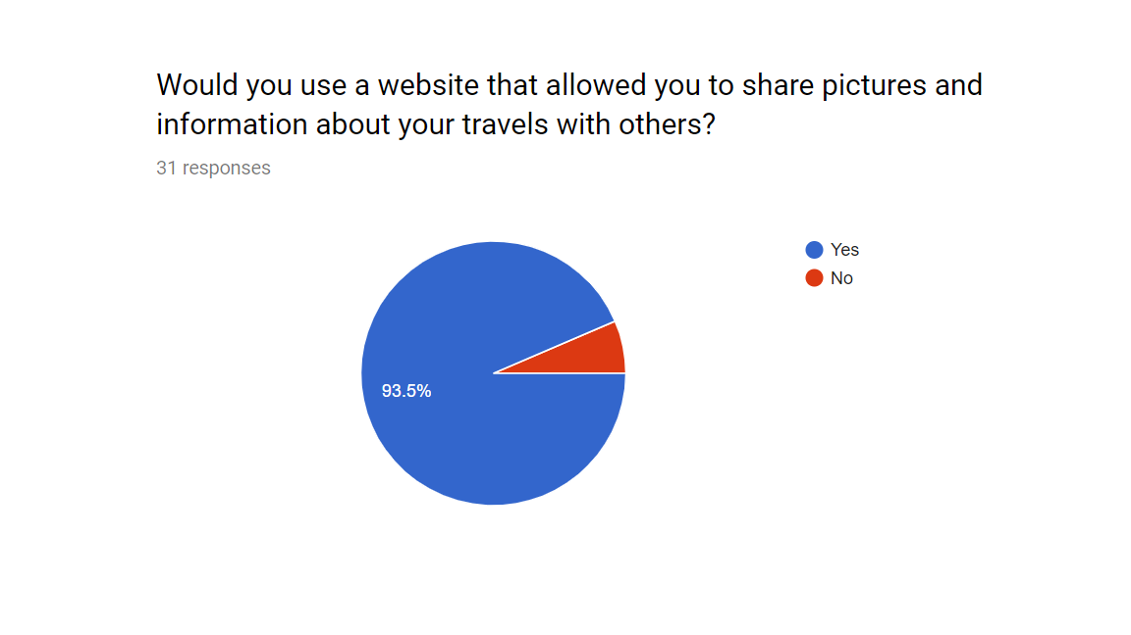

This question was quite direct, we simply wanted to see how interested the stakeholders would be in our website now that they had answerd the previous questions. Thankfully the large majority , almost 94%, said that they would be interested in using the website.

1. **How would you want these locations presented?** 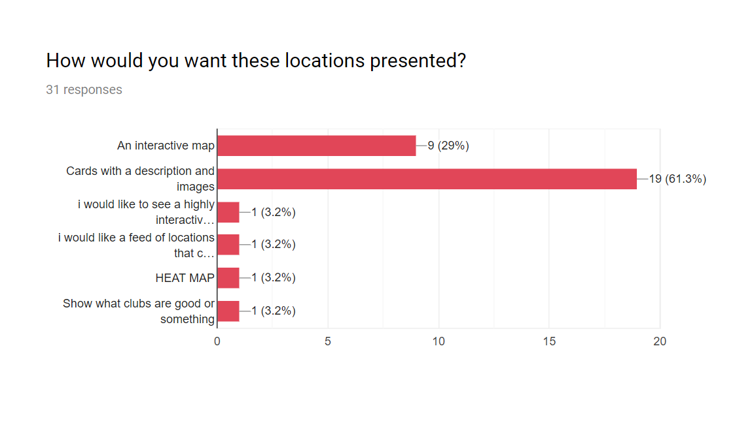

Our next question was to see what presentation would be preferd, our initial ideas were to have the posts show on a google map api utalising markers. Our other idea was to have ‘cards’ that would contain a picture, descritpon, would show the rating of the post and potentioally some other features. We also had the option for the participants to put there own ideas here as we only had the to.

The majority of the feedback told us that the card idea was the most popular with the interactive map getting some interest. As far as the user sumbitted ideas go a heat map is an interesting idea, however probably unviable other than that we found the other ideas left to be unhelpfull.

1. **What other features would you expect from a website like this?** 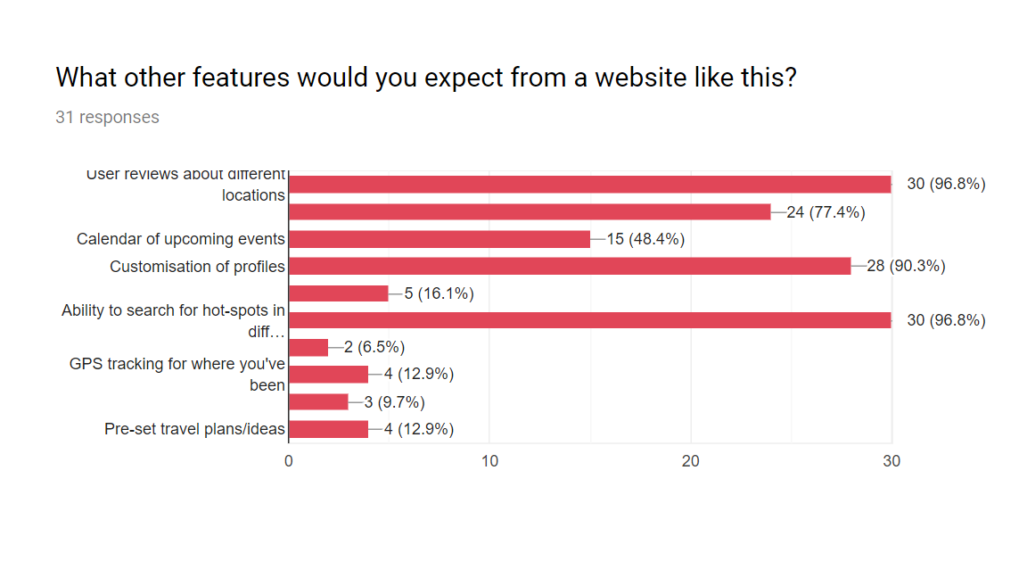

Finally we had a list of features left over with that we were considering implementing. From these there were two that really stood out, user reviews on various locations around the world and also the ability to search for hot-spots (being able to search for bars in rome for example). The next most popular feature on the list was customizable profiles pages and just behind that was a recomender system. Finally having a calendar of upcoming events you were going to attend also recived some interest but not enough it be considerd an important feature.

## Features

From this survey we were able to establish a list of faetaures and how important they would be to the website.

|  |  |  |  |
| --- | --- | --- | --- |
| **Must** | **Should** | **Could** | **Would** |
| Allow users to register accounts | Administer accounts can remove inappropriate posts | Allow users to flag posts as inappropriate | Pre-set travel plan ideas |
| Registered users can post pictures and descriptions of places they have been | Comments and discussion on events page | Calendar of events on profile page | GPS tracking of where you have visited |
| Rating system out of 5 stars and ability to leave comments on these posts | Recommender system for search | Recommend travel locations based on past travels | Social Media integreation |
| Allow users to organise and create and sign up for events |  | Administrators can delete and suspend accounts |  |
| Forum/Discussion board |  |  |  |
| Search feature, allow users to search for locations and events |  |  |  |
| Customizable profile pages |  |  |  |
| Administrator accounts |  |  |  |

# Specification of main functional subcomponents

## Requirements specification for common elements

The ultimate travellers home. Creating a customised online web-based interactive system, which provides an environment for travellers to post about their travel locations, review travel locations whilst also supporting the arrangement of future travels (either buddying up or as part of a larger group) and social events. The aim of this web application is creating a home for travellers to open up and show off their greatest travels with their friends and family. To go a step further and provide the ability to grow their travelling network. Based on current based web systems for this type of application, we have discovers unique points for which we could improve our system on. Followed with a survey for travellers, we asked many questions to help us discover which people will want and aspect from this kind of site.

## Team system specification

For our project we have decided to do a website aimed at connecting people who travel around the world. We want them to be connected to keeping each other up to date on their travel trips they are doing personally and being able to share them. We have individual tasks and single tasks with everyone getting a subcomponent to complete. But first we need to talk about our group component below is our group work:

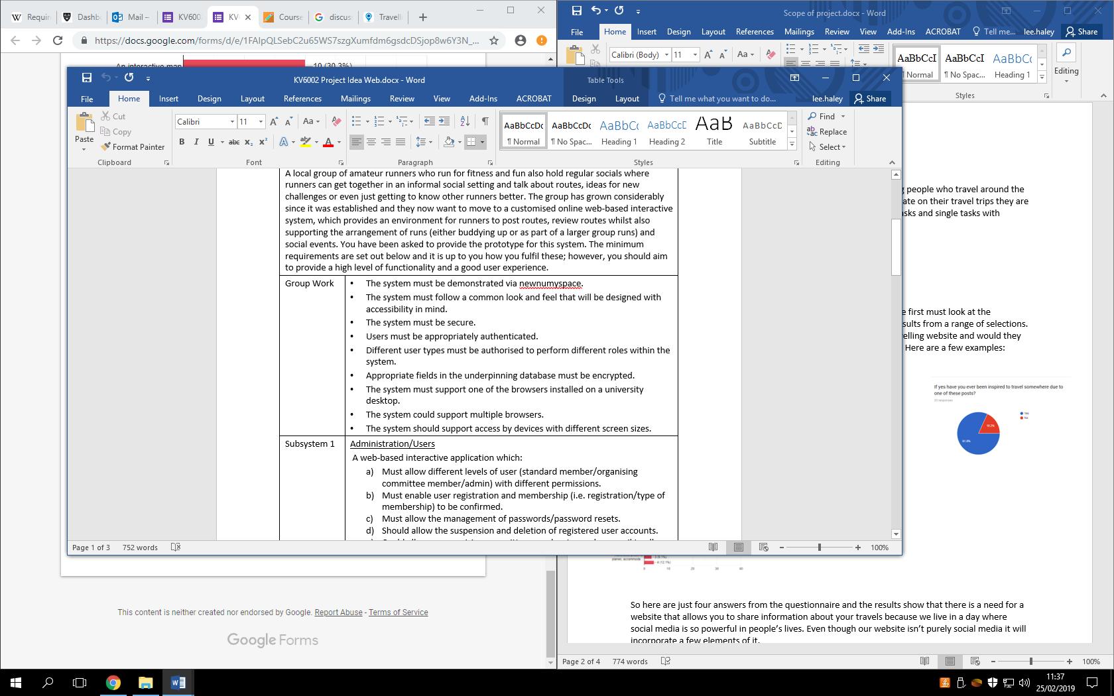

This is our group work that we are going be needing to do for our group project these tasks range from security, where it is hosted, the look and feel of the website and functionality of the website.

### Stakeholder questionnaire

To get the idea of our project and choosing of the subcomponents we first must look at the standards we got advised by the stakeholders these are a range of results from a range of selections. The stakeholders are members of staff, consumers, people who are interested in travelling, project supervisor and group members.

The question’s varied from if they wanted a social media style of travelling website and would they be alright with sharing their information of places they have been to and what features they wanted to see on the website. Here are a few examples:

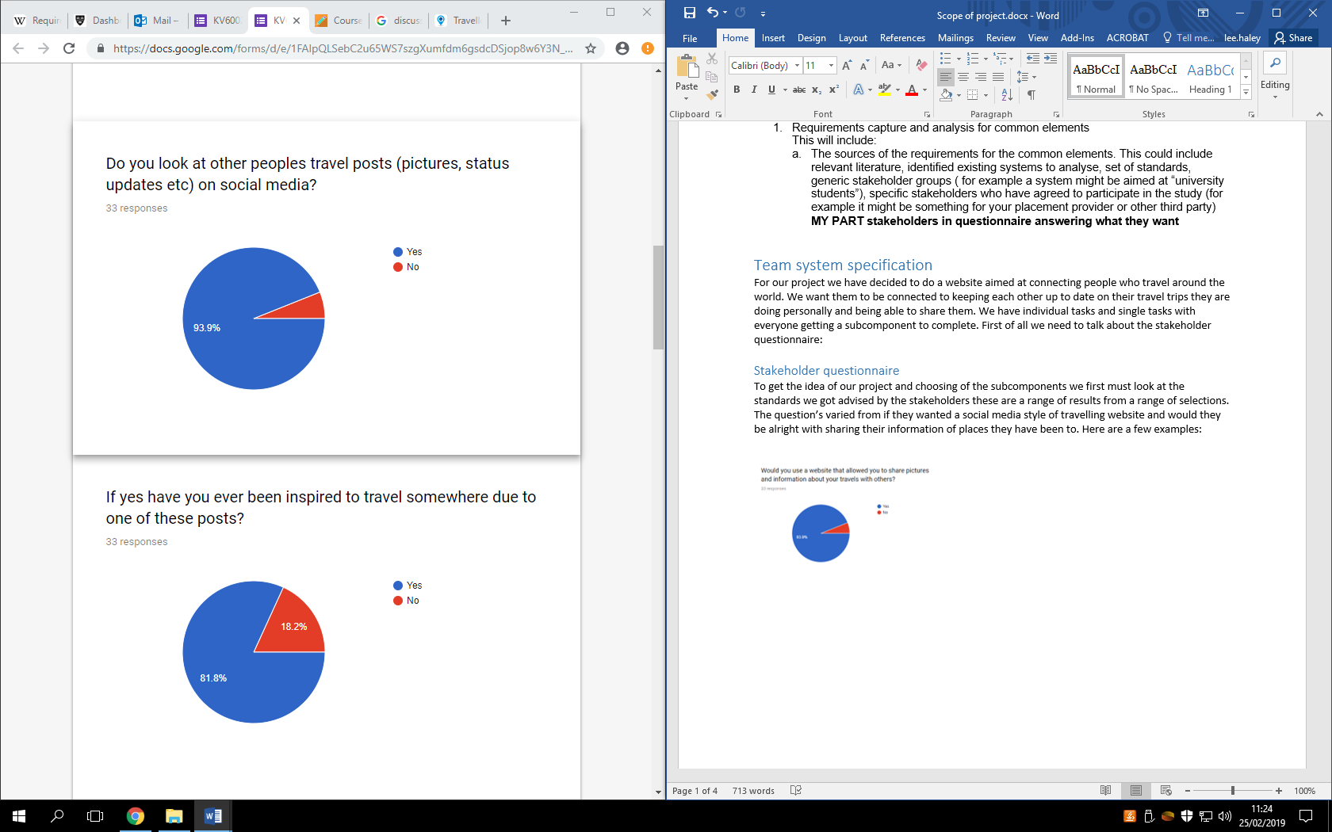

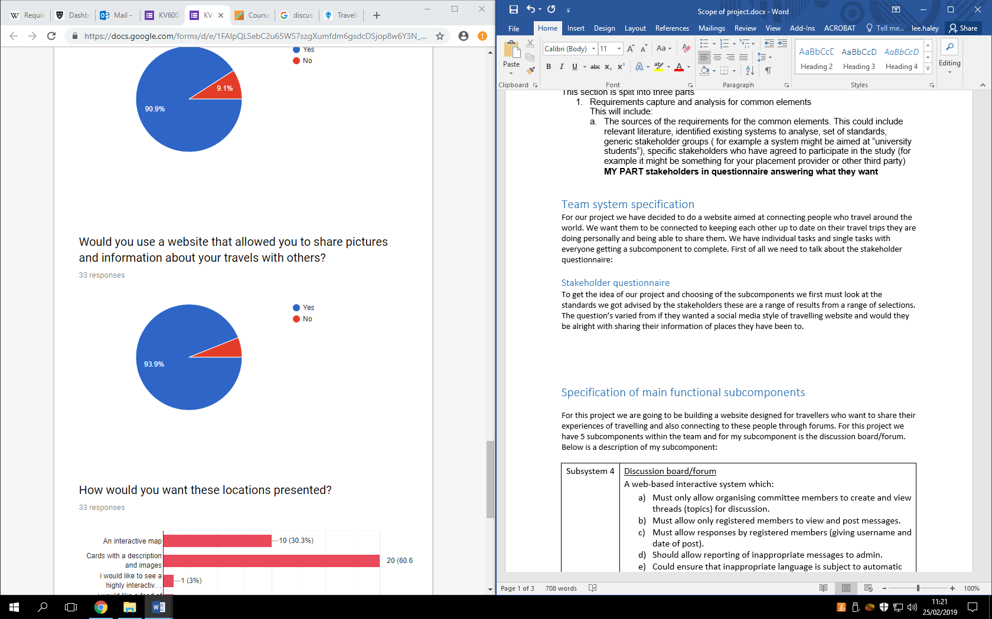

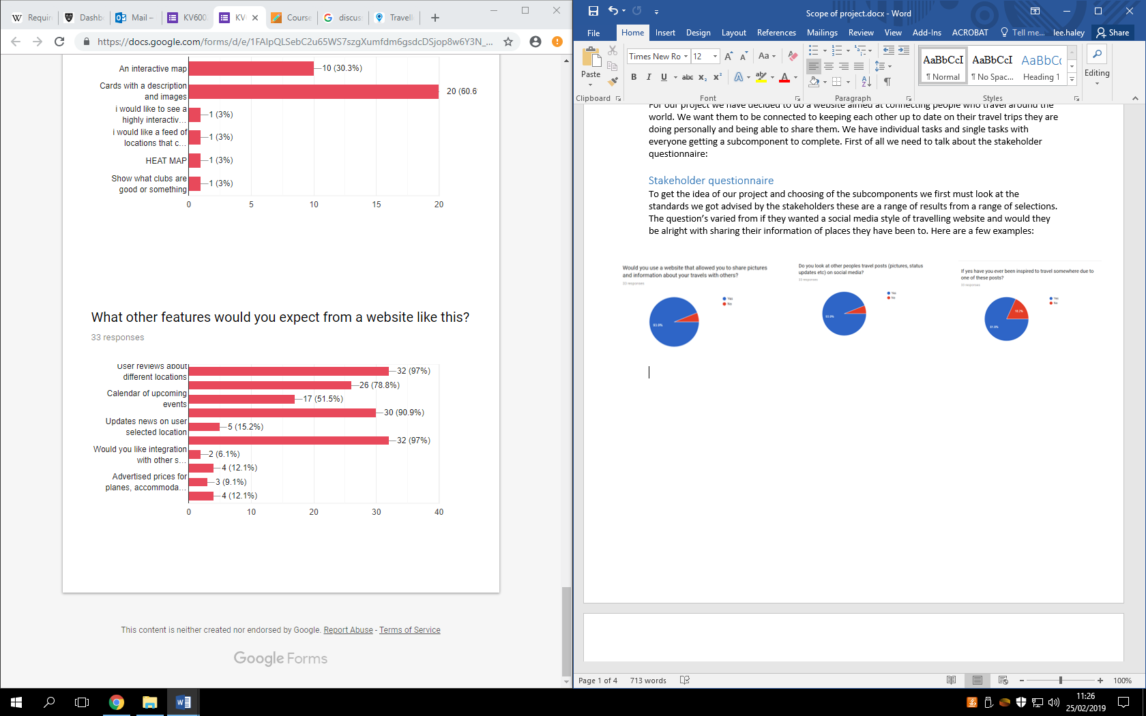

So here are just four answers from the questionnaire and the results show that there is a need for a website that allows you to share information about your travels because we live in a day where social media is so powerful in people’s lives. Even though our website isn’t purely social media it will incorporate a few elements of it. The reason why we have used a stakeholder questionnaire is because they are good way to collect data from a range of people to see what they want and these people who we interview are key to our idea succeeding so there input is vital. Questionnaires can be designed and used to collect vast quantities of data from a variety of respondents. They have a number of benefits over other forms of data collection: they are usually inexpensive to administer; very little training is needed to develop them; and they can be easily and quickly analysed once completed. (Birmingham, P. and Wilkinson, D., 2003)

So with all these results we refer back to our group work which are the objectives that centre on the functionality, look and feel and the security of the website. Given the results we gotten back I think the objectives we have set ourselves will please the demographic we are trying to aim for.

### Relevant systems

For getting this idea we needed to make sure there was a gap in the market and that

#### Travello

First of all we have travello which is purely an app which allows travellers to connect with each other. You have to download the app to access the whole system as the website just gives it a description of what it is. A social network for travellers Maybe you’re a backpacker, a solo traveller, a digital nomad or maybe you’re not even travelling right now but would love to meet travellers nearby? It doesn’t matter what type of traveller you are, on Travello you can tailor the app to create the community you want (Travello, 2019). This is what it says on the first page of the website it is promoting that it is a social network for travellers and it is for anyone for any type of need it is heavily promoting that this app is creating an enjoyable travel community. Below is what the app looks like:

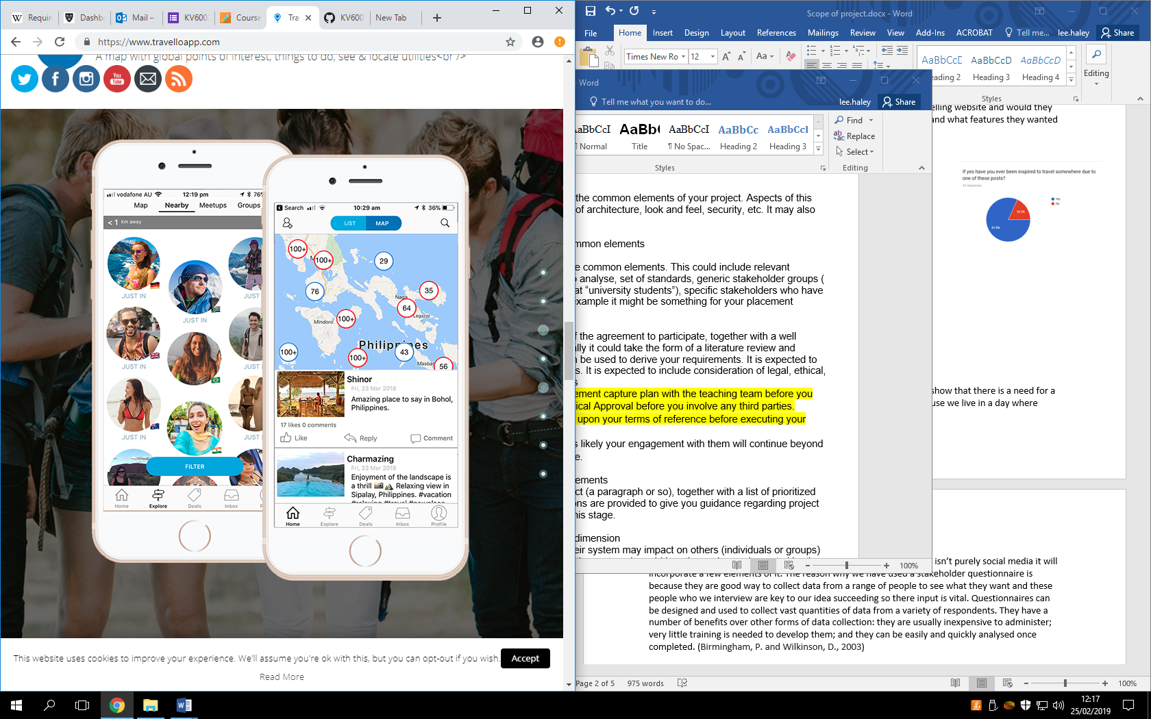 (Travello, 2019)

The app has many features it has map of the world and pretty much every place that is of a travellers interest all has many waypoints of medical centres, ATM’s, points of interests, hotels and social feed which includes interest groups. Travello say this about their map: The ultimate global travel companion map is now on Travello! Locate attractions, hostels, campgrounds, transport, nightlife, restaurants, shopping, fuel stations, things to do, places to see, local businesses and much much more to come! This interactive travel map is your vital trip planning companion feature. Great for backpackers looking for hostels, campervan stops or just an urban tourist looking for things to do in a city.

It has a lot of functionality but the design of the app is a bit too clustered it almost has too much information for the app itself to contain. Nether the less though it has a lot of functionality on it and the functionality it has is perfect example of what we are trying to accomplish but obviously the main difference and why travello has been included in my research is because it is an app, this app is also being targeted for people in the united states of America because when you sign up to the app you need to put in an American phone number so there is a gap in the market for travellers in the UK that need a system like this.

#### TripAdvisor

For our next website that we have market researched is TripAdvisor. TripAdvisor is the most successful and well known travel website in the world if you want to know about a hotel or a restaurant in a different country you’re travelling to you are extremely likely to use TripAdvisor. It has many functionalities to it obviously it is best known for leaving reviews but it has many lists of things to do, restaurants, flights, package holidays and the list goes on. Here is a look at the opening navigation bar you’re met with on the home page:

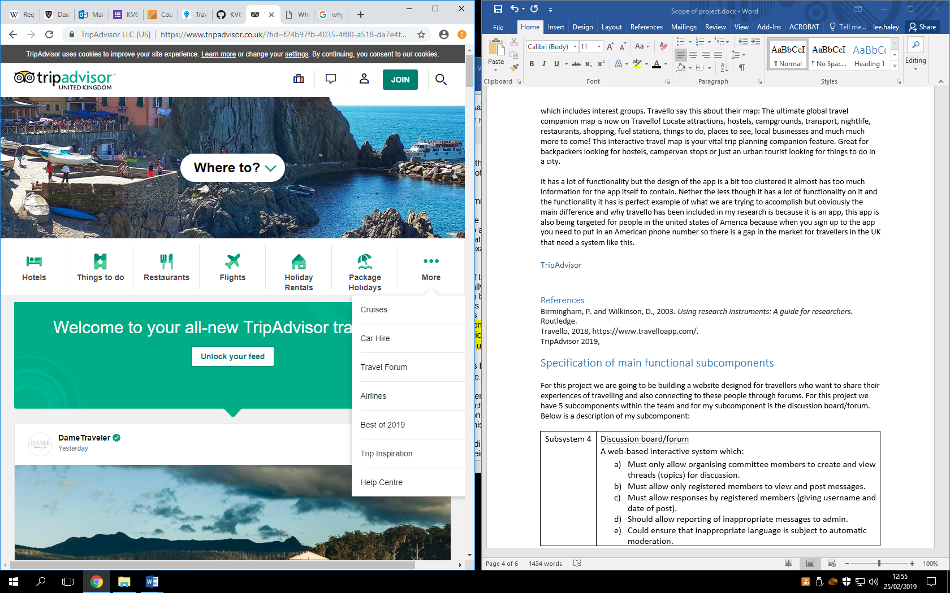(TripAdvisor, 2019)

As you can see here it has many options the ones I listed before and it has travel forums, car hires, best of 2019 etc. just at the bottom of this screenshot you can see the start of the social feed they have within the website which is a feature we want to have. TripAdvisor has a lot of the functionality we are trying to accomplish within our website it has the points of interests, the social feed, discussion forums. It is however a very long website length wise and you can often feel like your scrolling for minutes just to get to the bottom of the site

## Relevant literature

For our project we needed to expand our little knowledge that we already know about the travel sector and whether it will be good for a website with social media components specially for travelling. For this I used: what do we know about social media in tourism? A review (Zeng, B. and Gerritsen, R., 2014). Obviously when we were thinking about this idea we wanted to target a demographic that is very in at the moment and we thought social media and sharing experiences is one of the staples of people’s lives at the moment. Social media is changing the tourism culture. Paris (2011, 2012a, 2012b) has concentrated on backpackers using social media, and even coined a new word “flashpacker” to describe a backpacker who relies heavily upon social media in his/her entire travel process including before, during and after travel (Zeng, B. and Gerritsen, R., 2014). So obviously people use social media heavily when on holiday so why not make a website that has some fundamentals from that and add even more stuff centred around the travel industry.

We also needed to look at the fact we needed to connect our users and why that’s such a vital part of our project. Social media is important for consumers to acquire information but also for generating their own content to communicate with others (Zeng, B. and Gerritsen, R., 2014).

# The legal, social, ethical and professional dimension

## Introduction

During the course of this project, developing a system that will usually involve user interaction will inevitably bring about a range of legal, social, ethical and professional issues which will need to be carefully considered and discussed to help prevent any major consequences from occurring that may negatively impact our system. The current system which is intended to be built is an online web-based system for travellers. This document will be divided into several sections which will give a detailed overview of the relevant legal, social, ethical and professional issues which are important to highlight.

## Legal Aspects

### Data protection

One legal aspect that is important to be aware of is the data protection act which is a law that has been implemented to dictate how organisations should handle the personal information of their consumers. Any organisation which uses personal data must follow a certain set of rules, these rules state personal information is:

* Used fairly, lawfully and transparently
* Used only for specified purposes
* Used in a way that is adequate and relevant
* Accurate and up to date
* Maintained in a secure and safe manner which includes protection against unauthorised use, access loss or damage (GOV UK, 2018)

Due to the fact users will have to register with our online web system to use all the functionalities, data protection is a crucial aspect that all members of the group will need to be aware of to comply with this policy. One major advantage of complying with this act is that it will help to build trust and confidence with our users as if we are able to ensure any personal information we obtain is able to be kept safe and secure, users are more likely to consider our service to be reliable and will more likely register with our website without fear of any consequences. Whereas failure to ensure customer security will destroy the trust the user may have had and will prevent any future users on placing their trust on our system (Niles, 2011).

Furthermore, if this system was to go live then complying with data protection will help prevent an organisation from losing millions as breaching this act can cause a business to receive potential fines (Niles, 2011). Overall data protection is an important legal aspect that must considered when developing the prototype of this system or even the live version to help prevent any negative impacts from occurring such as financial loss, lack of trust from users, an organisation receiving a disastrous reputation etc.

### Copyright

Another legal aspect that needs to be avoided is the issue of breaching copyright laws, copyright laws in general have been implemented to specifically restrict people from copying/plagiarising work from other people and claiming it as their own (Ukessays, 2016). Because the internet allows users to freely search and download huge amounts of information onto their computer, this had made copyright a difficult issue to manage effectively. As a result, when developing our web-based product it is crucial for all members of the group to avoid using any logos/images that have been copyrighted or to completely plagiarise any work from another user as not only can it bring legal problems such as being taken to court or paying compensation. But also, copying someone else’s work and claiming it as your own betrays the idea of fair play which is viewed as ethically/morally incorrect (Ukessays, 2016).

However, it is important to note there are certain exceptions regarding copyright. For example, a person can copy small amounts of work if the use is non-commercial research or private study. Furthermore, criticising or reviewing copyrighted work is permitted under the use of ‘fair dealing’. Overall copyright rules show the margin of error is small as completely copying work is unacceptable, copying small extracts can be acceptable depending on the scenario and the context around it. This also shows if any member of the group does use some else’s work in acceptable terms then they must assess and decide if the work they are using will cause any financial impact on the copyright owner because of their use(GOV UK, 2018).

### Social and Ethical Issues

Regarding the topic of social and ethical issues which needs to be addressed, one issue that needs to be considered is an established level of integrity and trust towards the users of this system. A normal level of integrity includes the concept of being completely honest with the users of our system by providing correct and accurate information on the quality of the product, what features the product offers and how it works. By being open and honest, as well as being committed to treat every user fairly and equally. It will help to build and maintain a healthy relationship between the developers of this system (our group) and to potential users who may be interested in our product. By maintaining this level of trust between ourselves and to other users, it will be an important factor regarding the overall success of our product as keeping the users of the system satisfied will be hugely beneficial as they will continue to use system on a regular basis and may possibly inform other users to use the product which will bring more exposure that will be crucial if this system was to be funded and go live (Oster, 2019). Failure to maintain the usual standards of integrity and honesty with our consumers can cause a range of severe consequences to occur. One potential consequence that can occur is the complete breakdown of trust from our consumers which would cause current users and future potential users to permanently not use our product as well as any products we may release in the future as users may decide to never place their faith within us ever again. Another consequence of this would be income loss as users who decide to stay away from our product will decrease the overall income of the organisation. Furthermore, users who feel cheated or feel we have been unfairly dishonest towards them may decide to take this matter further by going to court or by issuing libel charges that would cause us to lose a significant amount of money and would also tarnish our reputation to the point where it would be difficult to reverse (Oster, 2019).

In addition, another social/ethical issue that needs to be considered is the subject of web accessibility. In general, many people usually take for granted their ability to operate a computer/laptop without any problems but unfortunately there are certain people who do not have that luxury as they may have a disability that prevents them from effectively using a computer as compared to the rest of the population (Lunka, 2019). As a result, this raises concerns in regards to our own system as using it will require a user having to use a computer/laptop to access the product which for the average person may not pose any problems but for anyone who currently has a disability, this may prove to be a hindrance as they may struggle to navigate through the website. As a group this is an issue we will have to discuss in more depth in which we may have to rethink some of our ideas in terms of the overall design of the website, how we can improve the user interface, to discuss in more detail on the colour scheme of the system and to decide which colours will be appropriate especially for users who may be colour blind to specific colours etc. One possible solution that we can implement to help individuals with disabilities is to possibly use screen readers which for anyone who is visually impaired, this will be beneficial as a screen reader will audibly dictate the contents of a webpage to the user (Lunka, 2019). By implementing a feature like this would be an advantage as it would mean we can expand our target audience by being able to include as many people who can use our system to satisfy their needs.

However, if we are not able to implement any effective features that would help improve web accessibility then there may be a scenario in which as a group we may have to compromise and utilise a risky approach of acknowledging that some users will not be able to use our system. Although as mentioned earlier in this section, this approach could potentially be problematic as it would mean certain individuals who may have an interest in using our site will have to miss out and as a result, we may not be able to attract a large amount of users to use our prototype product and in the scenario in which this system was to go live. A big organisation would potentially lose out on huge money if the web accessibility of this site was not versatile enough to accommodate everyone.

Privacy invasion is another social/ethical issue which needs to be taken into consideration especially since our system will require users to register with personal data such as usernames, passwords etc. Online privacy in general is hugely important for website visitors and users as they don’t want their privacy to be invaded by unauthorised users or any organisations. Which is why businesses must ensure to their consumers that not only will their information be kept confidential but also to ensure their personal data will not be accessed by hackers or by any unknown user (Angus, 2014). As a group, we must discuss and achieve a conclusion on which personal information will be necessary to collect and which information will be considered as unnecessary to obtain. One action that could possibly be taken to help gain the trust of consumers would be to implement an effective privacy policy which would benefit our system as it will reduce the level of scepticism within our users and users will more likely sign up without fear of their privacy being exposed. By implementing this policy, we will be able to display to our users on how we collect their information and how we will manage their information on a daily basis (Angus, 2014).

On the other hand, another form of action that could be taken would be to use a range of security validations within our system to ensure to our users, high level security techniques will be implemented to prevent any unauthorised users with malicious intent to access their information. Since this system will be created in PHP we can put in place different types of validation methods to improve the security of our system such as hashing which is a technique to storing passwords securely whilst making it impossible for a human to read it (Greenberg, 2016). Failure to implement any of these methods will lead to a risk of a user’s personal data possibly being taken by potential hackers which will prevent our consumers from ever placing their trust and faith on our system, this links back to the data protection legal issue which was mentioned earlier on.

### Professional Dimensions

Regarding the professional dimensions, the compatibility aspects of the web system will be important as when the system is eventually finalised, it will be crucial for the system to operate on different versions of operating systems, web browsers e.g. Windows, Linux, Internet Explorer, Firefox, Safari etc. by making this system compatible with different types of browsers and operating systems we will able to incorporate all users who will have different types of hardware, software, browser versions etc. By doing this it will reduce the chances of a user of not being able to access our site regardless of the fact they may have updated or outdated technology. If we don’t make the system compatible enough then there is a huge chance that we will risk alienating the majority of our audience which as a result, will attract less users towards the website (Ukessays, 2016).

Furthermore, another professional aspect that will be crucial is the consistency of our CSS (Cascading style sheets) implementation, it will be necessary to have a specific style that will be applied consistently through different webpages e.g. blue background with black font. Using a consistent style will make the website appear highly professional to visitors of the site, it will also help to make users become familiar with the website as they will look at certain colours/themes and will instantly recognise, and link these details towards our system. The consequences of not delivering a consistent style will make the overall appearance of the system appear unprofessional and incoherent with the rest of the design as if one webpage had a certain set of colours e.g. red and black background. And another webpage had a different set e.g. yellow background. Not only will this look poorly organised but will also confuse the user and will be less likely to visit the site more than once (Wake, 2016).

### References

GOV.UK. (2018). *Data protection*. [online] Available at: https://www.gov.uk/data-protection [Accessed 12 Feb. 2019].

Bamford Niles, C. (2011). *Advantages And Disadvantages of Data Protection Registration - Blog ¦ TheCompanyWarehouse.Co.Uk*. [online] Blog ¦ TheCompanyWarehouse.Co.Uk. Available at: https://www.thecompanywarehouse.co.uk/blog/advantages-and-disadvantages-of-data-protection-registration [Accessed 12 Feb. 2019].

Ukessays.com. (2016). *Legal social ethical and professional issues*. [online] Available at: https://www.ukessays.com/essays/information-technology/legal-social-ethical-and-professional-issues-information-technology-essay.php [Accessed 13 Feb. 2019].

GOV.UK. (2018). *Exceptions to copyright*. [online] Available at: https://www.gov.uk/guidance/exceptions-to-copyright [Accessed 13 Feb. 2019].

V Oster, K. (2019). *List of Ethical Issues in Business*. [online] Smallbusiness.chron.com. Available at: https://smallbusiness.chron.com/list-ethical-issues-business-55223.html [Accessed 14 Feb. 2019].

Lunka, R. (2019). *Ethical Issues in eCommerce: Are you violating any of them?*. [online] Nchannel.com. Available at: https://www.nchannel.com/blog/ethical-issues-in-ecommerce/ [Accessed 14 Feb. 2019].

Angus, B. (2014). *6 Steps to an Effective Ecommerce Privacy Policy | Practical Ecommerce*. [online] Practical Ecommerce. Available at: https://www.practicalecommerce.com/6-Steps-to-an-Effective-Ecommerce-Privacy-Policy [Accessed 15 Feb. 2019].

Greenberg, A., Barrett, B., Lapowsky, I., Tufekci, Z., Newman, L. and Dreyfuss, E. (2016). Hacker Lexicon: What Is Password Hashing?. [online] WIRED. Available at: https://www.wired.com/2016/06/hacker-lexicon-password-hashing/ [Accessed 16 Feb. 2019].

Wake, L. (2016). Why is consistency important in web design?. [Online] Digital communications team blog. Available at: https://digitalcommunications.wp.st-andrews.ac.uk/2016/04/07/why-is-consistency-important-in-web-design/ [Accessed 17 Feb. 2019].

# The Project Tasks and Deliverables

## Agreed Deliverables

### Usability

For the usability of the application, we will aim to deliver a product which is smooth and easy to navigate around. Keeping it simple and robust. The code itself will be heavily commented and kept clean as possible by finding the best way to code functionality for which keeps the code clean, easy to understand and most importantly easy to integrate with other systems. This is important as we want the product to be easily fixable if any issues do occur, which may be handled by people whom may not code the product initially. Another importance of making sure the usability is good would be encase of expansion in the future, this should be an easy transition if this does occur.

### Code of Conduct

* Everyone in the group should ensure that they can be contacted easily by other members of the group by giving them adequate contact information.
* When working in a group, please treat other members of the group with courtesy and respect their opinions, even if you do not necessarily agree with them.
* You are expected to make full and fair contribution to the work of the group.
* When you agree to undertake a task that has been assigned to you by the group you must try work to the agreed deadline since failure to do so could impede the progress of the whole project.
* You have the right to challenge other’s opinions but please try to do it in a non-aggressive way. If there are 2 or more ideas for a solution of the program or project then there can be a vote by the other 3 members of the group.
* It is your responsibility to attend all meetings arranged by the group to advance the project, and to arrive at those meetings on time. If you can’t attend a meeting of the group, you should consider providing your input in written form and providing this to other group members before the meeting. Failure to make a meeting results in bringing treats to next meeting.
* Members shall act honestly and promptly and in such a manner to ensure that their client is not misled, offering an appropriate outcome and solution to the user’s needs and requirements.
* Members shall claim expertise only in areas where their skills and knowledge are demonstrably adequate;
* Be accurate in reporting and realistic in forecasting
* Accept responsibility for their actions and act with due skill, care and diligence.
* Members shall co-operate fully with the team and submit promptly any information the association may reasonably require.
* Promptly submit to the group any information that could assist in the completion of the project.

### Quality Control

* All work will be pushed to the GITHUB Repository – (<https://github.com/aowsr/KV6002-Team-Project>).
* Documents will use a footer displaying the authors name and student ID.
* Code will be separated by comments that will state what section of the code it is for and the purpose of it.
* Indentation will be used to make code look clean.
* Variable names will be clear however not long nor complex.

### Meetings

We have regular meetings, twice a week. For which all members must attended, unless special circumstances. Specific days not set due to work and university schedules. The meetings will consist of a brief catch up to see what members have to done and if there any barriers. Then achievable milestones will be set for everyone to be completed for the next meeting. Constant communication will be kept after meetings via group chats.

### Group Work

Skills audit will be conducted to help understand each other’s key areas to help distribute work load. The actual group work will be divided fairly and constant support will be available from each other. Group work can occur after meetings or if the individual knows their part can complete in their own time under the timeframe provided. All code/work will be clear and commented so no issued will arise when collaborating work.

## Resources List

|  |  |
| --- | --- |
| **Product name** | **Product type** |
| PHP Storm | Software |
| Microsoft Office | Software |
| GitHub | Respiratory |
| JavaScript | Language |
| Ajax | Language |
| PHP | Language |
| HTML | Language |
| CSS | Language |
| BootStrap | Software/CSS Library |
| PHPMyAdmin | Database |
| Newnumyspace.co.uk | Hosting site |
| High performing computers | Technology |
| Adobe PhotoShop | Software |

## Testing procedures/strategy

### Black box testing

#### Introduction

Black box testing is applicable to integration testing, system testing and acceptance testing. Black box testing also known as Behavioural Testing, test the functional or non-functional structure/design/implementation of the system [4]

#### Testing

|  |  |  |  |  |  |  |
| --- | --- | --- | --- | --- | --- | --- |
| Test Number | Test | Expected Outcome | Actual Outcome | Action for improvement | Date Tested | Date Improved |
| Example | Home Screen | Click the ‘Home’ button, this should take you to the home page. | Takes you to the home page | N/A |  |  |
|  |  |  |  |  |  |  |

### Decision Tables

#### Introduction

Decision table testing is a testing technique used to test system behaviour for different input combinations. This is a systematic approach where the different input combinations and their corresponding system behaviour (Output) are captured in a tabular form [1].

#### Decision Tables

Functionality to provide a way for users to log on, or otherwise securely indicate their identity.

|  |  |  |  |  |
| --- | --- | --- | --- | --- |
| Conditions | Attempt 1 | Attempt 2 | Attempt 3 | Attempt 4 |
| Username | Correct | False | False | Correct |
| Password | False | False | Correct | Correct |
| Output | Error Message | Error Message | Error Message | Log on successful, moves on to next screen. |

### Unit Testing

#### Introduction

Unit testing is a level of software testing where individual units/ components of a software are tested. The purpose is to validate that each unit of the software performs as designed. A unit is the smallest testable part of any software. It usually has one or a few inputs and usually a single output [2].

#### Testing

|  |  |  |  |  |  |  |  |
| --- | --- | --- | --- | --- | --- | --- | --- |
| ID | Function Scope | Test Case | Input Value | Expected Output | Pass/Fail | Tested By | Date Tested |
| 01 | *List features/functions that are tested.* | *Identify the test cases along with the expected results.*  ***Example****:*  *Test Procedure:*  *Login with a corporate user account.*  *Username: abc*  *Password: abc*  *Expected Results:*  *An error will be displayed for the wrong credentials.* |  |  |  |  | *dd/mm/yyyy* |
| 02 |  |  |  |  |  |  |  |

## 

### Integration Testing

#### Introduction

Integration testing is a level of software testing where individual units are combined and tested as a group. The purpose of this level of testing is to expose faults in the interaction between integrated units. Test drivers and test stubs are used to assist in Integration Testing [3].

#### Testing

**Component**

|  |  |
| --- | --- |
| Purpose |  |
| Test Description |  |
| Expected Results |  |
| Results |  |

### References

[1] <https://www.guru99.com/software-testing-techniques-1.html>

[2] <http://softwaretestingfundamentals.com/unit-testing/>

[3] <http://softwaretestingfundamentals.com/integration-testing/>

[4] <http://softwaretestingfundamentals.com/black-box-testing/>

## Risk Analysis

|  |  |  |  |
| --- | --- | --- | --- |
| Description of risk | Severity | Chance Of Occurrence | Analysis and solutions |
| Hard drive/Storage failure | Medium | Low | All work should be saved in multiple places. Multiple copies of document should be made per milestone progression, if document is lost you can restart from previous milestone. |
| Missed deadlines holding up other parts of project | Medium | High | All Group members should strive to meet deadlines, however missed deadlines are a high possibility as it is unlikely everything will go exactly to plan. The group will need to be flexible in order to work around this.  Additionally all deadlines should be approved by the whole group so that everyone feels likes they are obtainable. |
| Long deadline for project could mean a lack in early productivity or a dip towards the middle of the project. | Medium | High | The main way this will occur is if long deadlines are set for tasks, such as saying that a large part of the website needs to be done in a month. To minimize this we will attempt to set more smaller shorter deadlines, so instead of making a full page in a month set a deadline of a week for the search function then after that another week for the page content etc. This should productivity more consistent. |
| Long hours in Library could be detrimental towards the health of group members. | Low | Medium | No group member should spend more than 12 hours in a single day in the library, and should have regular breaks from work to walk around and get fresh air. Multiple breaks should occur during the duration of library session. |
| Drop in quality towards end of project. | Medium | Medium | If deadlines are getting close and things are not yet done then quality can begin to drop and style rules could begin to slip. To avoid this we will try to keep work consistent and as mentioned above shorter more concise deadlines will also help quality as group members will be focusing on one individual task. |
| Errors missed during testing. | Medium | Medium | All features should be tested by every member of the group at some point to make sure that everyone agrees that the code is as error free as possible. |
| Group member absence due to illness. | High | Low | If a group member was too become unwell and be unable to work a long or even short amount of time, it could be problematic for the project, as members could fall behind schedule. Deadlines and meetings to attempt to be planned as to mitigate the impact this will have if it was to occur. |

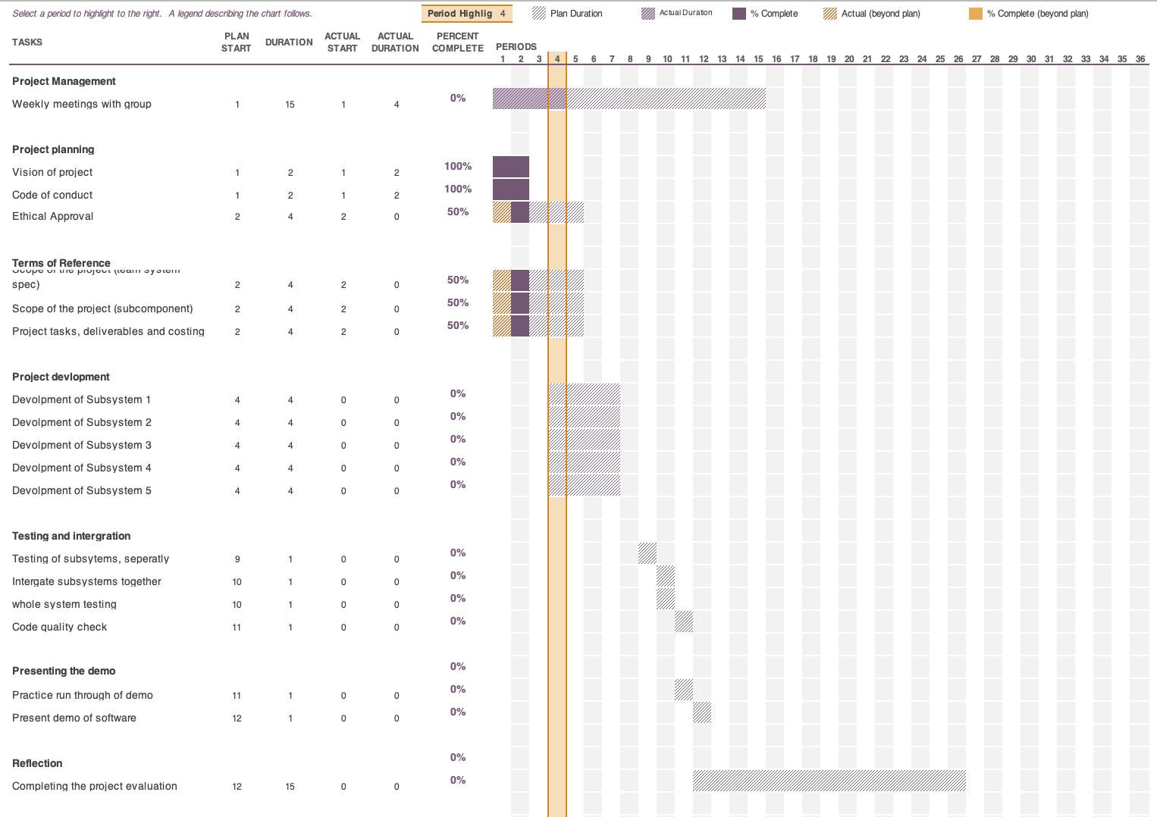Gantt Cha

Costing

## Importance of cost estimation

The reason for making an accurate and detailed estimate on project costs when working with a client/stakeholder is to help them determine if your offer is the most cost effective solution and that you are the most suitable person who understands their vison. the more accurate and detailed your estimates are the more chance you will win bids for contracts and increase profits in your business, however that does not mean you always underestimate your costs to win bids, you still need to make sure that you adjust your costs accordingly in order to make a respectable profit for your company. Furthermore you do not want to over-estimate your cost either as you are still in competition with over companies who want the contract.

Clients tend to want more work done while paying less for it and a contractor would want to do less work while getting paid more. That is why it is very important to find a balance between you and the client.

### Project cost techniques

Project estimations can be a stressful and scary process thinking of it as almost a life line for a company, getting them right is crucial. Stakeholders will only authorize a budget if they know that the estimates are established in a credible way. There are techniques in place which can make it more bearable to work out these costs. I will try to name and explain each technique briefly to get a good understanding of what they do, furthermore I will write the advantages and disadvantages of each one. Here are the 4 most popular techniques used today.

**Top-Down estimation** – The top-down approach is a useful technique in the early phase of a projects it provides the client a ball park estimate which in turn helps decide whether the proposed client offer is sufficient in the completion of the project. It involves deciding the total cost of the project then splitting it between the phases in the project to see if it will equally cover each one. There are arguments that this approach is severely inaccurate, as you have to guess the initial total first then keep the same total for the entire project without interchanging variables also it is not team friendly as opposed to the bottom-up approach.

**Bottom-up estimation** – Similar to the Top-Down approach this technique is more accurate. The reason for this is that instead of the upper management providing project objectives, the task is given to the team who decide all the objectives and tasks. The project manager will then use that to break down each phase and task then assign a cost and calculate a total budget from that. The challenge with using this approach is that you need to know all the details about each task in order to produce an accurate estimate, this can be very time consuming as you are working on a granular level.

**Analogous estimation** – if you are a company which has carried out many projects over the years, there is a good chance that there is a project which you worked on that is similar to a current project. This approach uses comparison from previous projects and providing estimates from them. If a website that you created last year cost £50,000 to complete you can look at specific tasks in that project and see which are similar to provide an estimate. This can be argued that even though there are similarities between past projects, each project is unique and could require more resources. However this approach is quick and inexpensive and can be used for projects without much detail.

**Parametric estimation** – As the name suggests the parametric approach uses variables to create parameters for estimation. The variables are taken from previous projects similar to the analogous approach however it is more accurate as you are using a wide data set which uses statistical relationships between past variables.

## The Estimation

#### Indirect costs

Firstly I need to work out the indirect costs of the project this can be the costs that the business incurs such as the rent of the premises, the utilities, software and hardware, and other fixed costs.

I have used Zoopla’s office space calculator (Zoopla, n.d.) to assess the square footage needed to house 5 employees with a small meeting room, kitchenette, small server room and a receptionist area. This will give me a reasonable estimate as I will be able to find the cost of similar offices on the market thus helping determine the daily costs of the premises. Below is a table of the values I entered which gave me an estimate.

According to (Dowse, 2015) “We find that an average of 80 to 100 square feet per person can creates a comfortable working environment.” This is between the specifications that the Zoopla office space calculator uses which means it’s a good source.

|  |  |  |  |
| --- | --- | --- | --- |
| Description | Dimension | Number of | square footage |
| Standard workspace Generous use of space | 95 sq. feet per person | Employees 5 | 475 sq. ft. |
| Small meeting Up to 8 people | 120 sq. feet | Rooms 1 | 120 sq. ft. |
| Kitchenette  No seating | 100 sq. feet | Rooms 1 | 100 sq. ft. |
| Small reception 1 receptionist | 150 sq. feet | Rooms 1 | 150 sq. ft. |
| Small comms/server room Up to 5 racks | 40 sq. feet | Rooms 1 | 40 sq. ft. |
| Total space required | | | 885 sq. ft. / 82.22 sq. m |

After determining the minimum square footage required for the premises, I was able to gain a rough estimate which aided me in choosing the most suitable premises. This is the building I found on Zoopla, very suitable as the offices are already equipped with all the hardware such as desks, computers printers and anything needed for a company to run. The utilities are also covered in the price, this would be the high speed broadband provided by virgin media’s fibre optic, electricity and anything else. The hub also provides these amenities

* MANAGEMENT SUITE
* FLEXIBLE MEETING SPACE
* SOCIAL MEETING AREAS
* BIKE STORAGE FACILITY
* MALE & FEMALE SHOWERS
* COMMUNAL KITCHEN

(Zoopla)

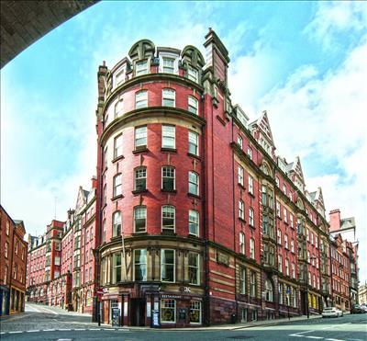

Milburn House, Dean Street, Newcastle upon Tyne, Tyne & Wear NE1

From

£1,152 pa

(£11.75/sq. ft. pa)

The Price is represented as £11.75 per square footage per annum, I would multiply this by the minimum required square footage which equals to 10,398.75 per annum then divide it by the time of project completion 21/02/2019 till 16/05/2019 which is 2 months 26 days (85 days)

$$885 sq ft*£11.75 sq ft=\frac{£10398.75 pa}{365.25}=£28.47*85 days=£2419.96$$

The total running cost for completing this project from start to finish would equate to £2419.96 or £28.47 per day.

### Direct Costs

Secondly I will need to figure out the direct cost of this projects, this includes labour costs, travel project-specific equipment/hardware and software.

For the labour costs I used the (Living Wage Foundation, 2018) Real living wage as it represents the true wage to live on rather than the national minimum wage.



(Living Wage Foundation, 2018)

I used Microsoft Project to input all the employees in the company which are the people that will be working on the project. I set their working rate as £9.00/hr which equivalent to the suggested wage.

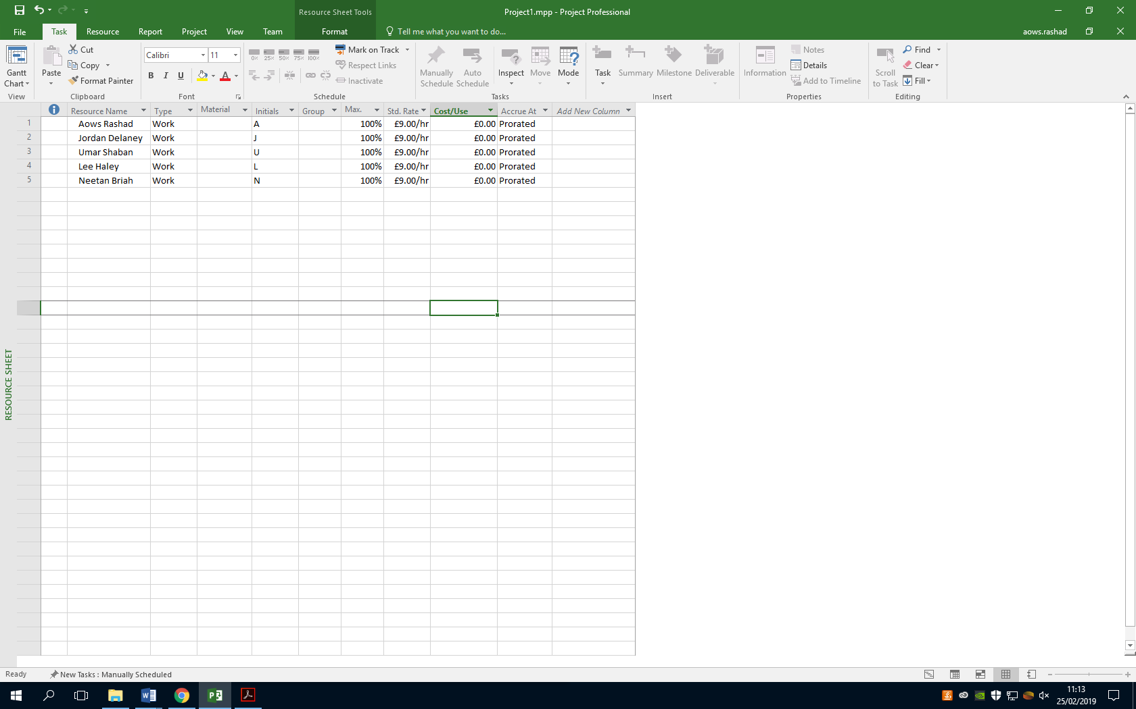

I then inputted all the tasks that the project will entail and assigned each person to a set of tasks and gave them an estimated date of completion, this game me a rough estimate of how many hours each employee will work to complete their goal. Microsoft project took care of not including non-working days such as weekends and also making sure that I don’t accidently assign an employee to two tasks thus overworking them. I then used the automated process of creating a report in which it gave me an accurate estimate of how much it will cost to pay the employees to complete the project. Another useful tool in this program is that I can choose when each task is completed and how much actual time it took them to complete it which will give me a better estimate as the project goes forward.

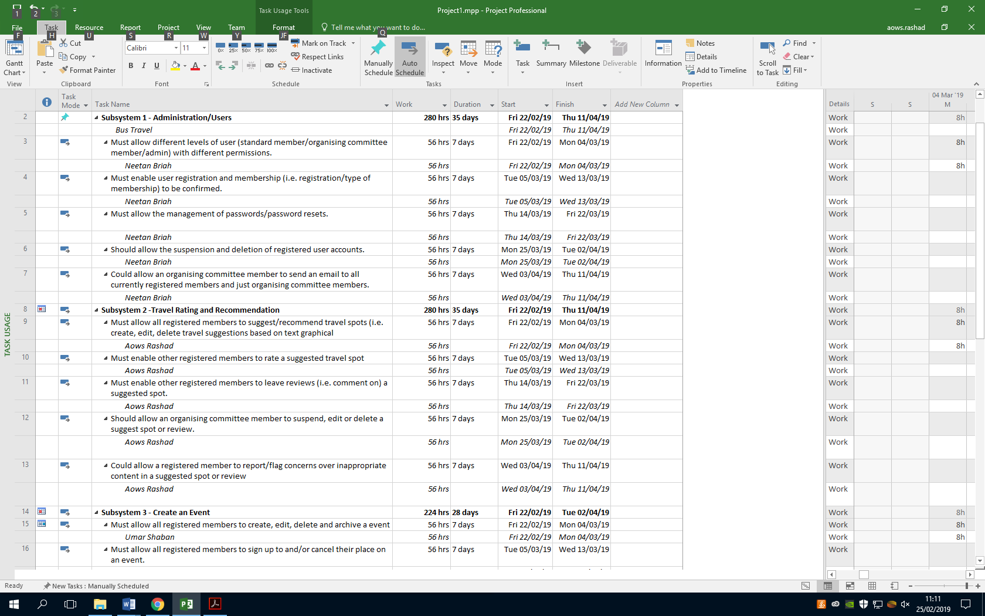

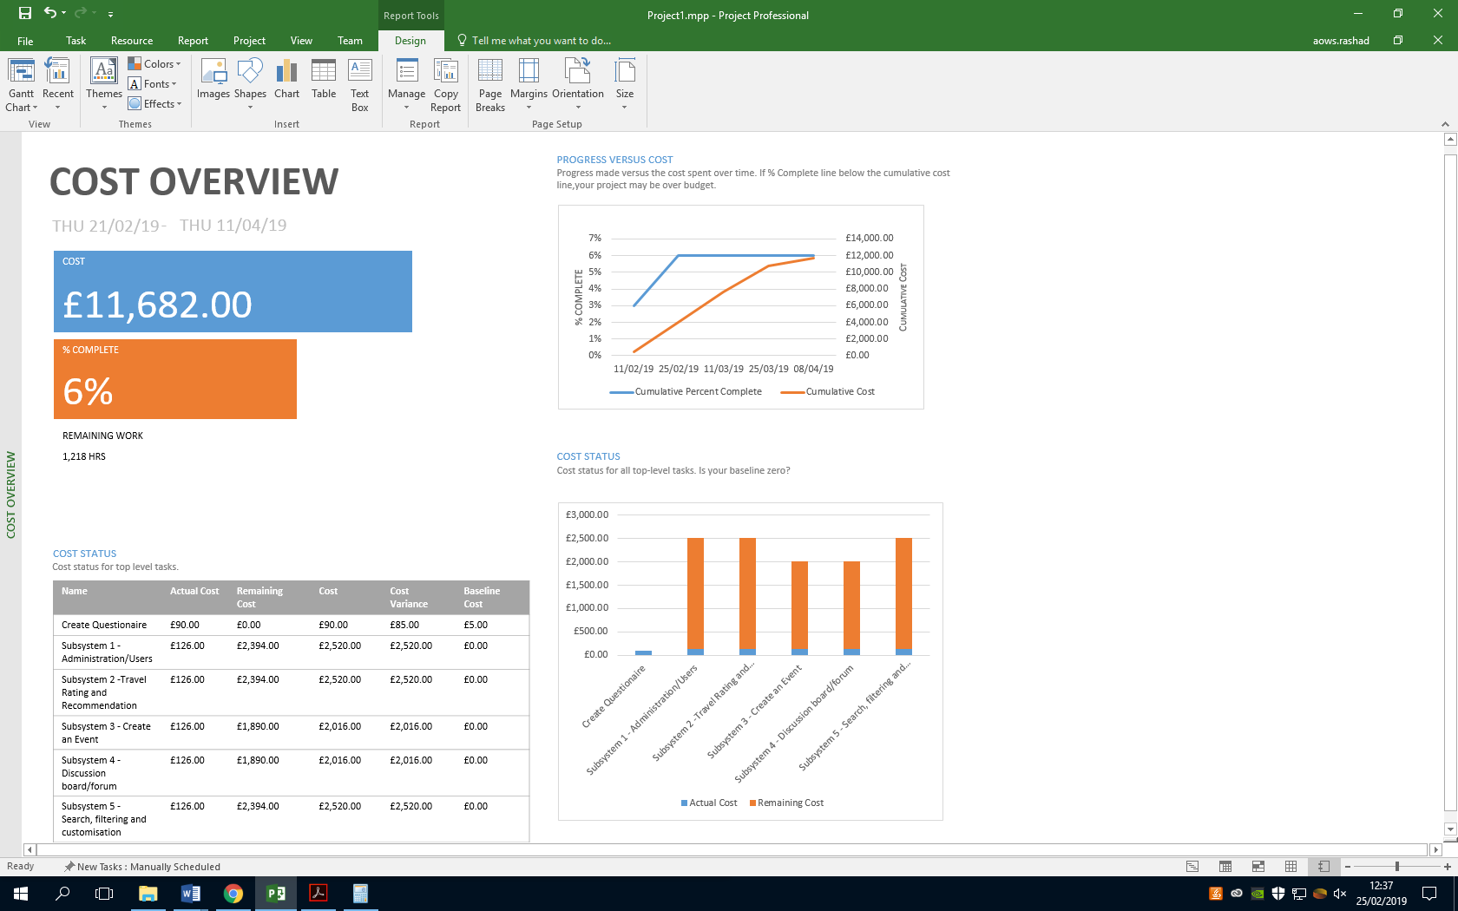This table shows the top level tasks for the project and provides the cost of how much it would cost for each task/phase.

You can see that the first Column (Actual Cost) is the amount of work which is completed and how much it cost as of then. The second column (Remaining cost) shows how much money it will cost to complete that specific task. The third column (Cost) shows the initial estimation of that task.



This bar chart on the right is another way to represent the cost of each top level task, the orange indicator is the remaining cost of that task and the blue indicator shows how much it has cost so far to complete a small percentage of the project. This bar chart is useful as it can show if the project will go over the estimation after completion.



Finally this represents the total estimated cost of the project which is £11,682.00.

## Domain and hosting cost

To find an estimate I used Amazon Web Services (AWS, n.d.) Calculator to give me and estimated price on running a server instance using their services.

The inputs I requested are for a web server with 1 instance based in North Virginia that will be used for 24 hours/day running Linux on m3.2xlarge which will be paid 1 year upfront.

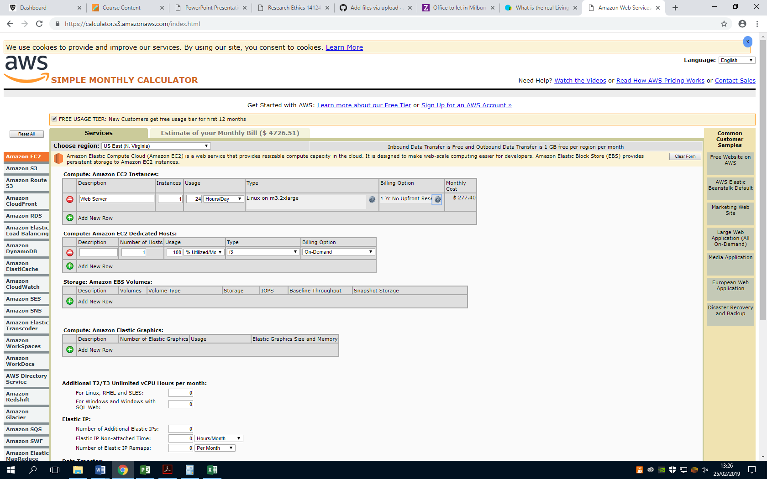

The Linux on m3.2xlarge will have 8 virtual CPU’s (vCPU), 30 GiB memory, 2 x 80GB SSD instance storage and High I/O speeds.

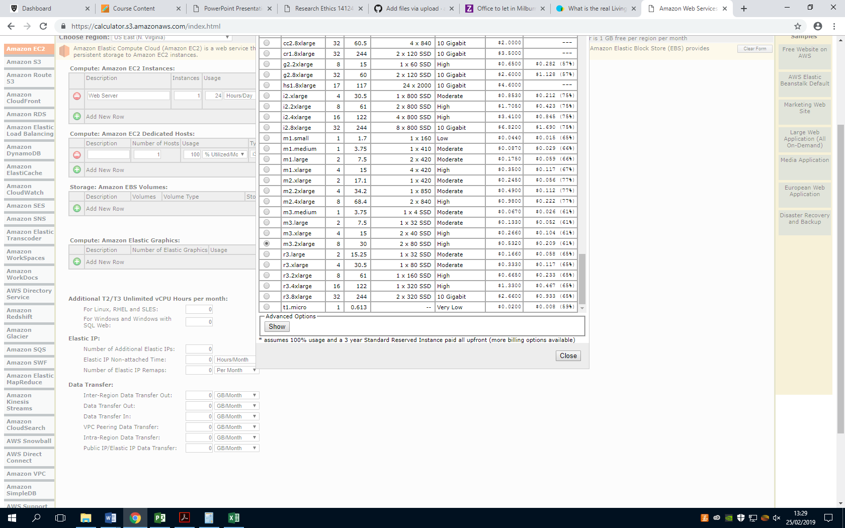



Above is the calculated total monthly payments for hosting a web server on Amazon Web Services

## Conclusion for Project Costing

The estimated premises cost is **£2,419.96** for the entire completion of the project and the estimated cost of employee wages for this project is **£11,682.00** adding these together would give me an overall ballpark estimate for the project. It would cost **£14,101.96** to complete this project and an additional **$4726.51** per month to run the website.

This is however a very rough estimate as unforeseen circumstances can occur that have not been accounted for which can drastically change the outcome of the project. It is however a good idea to create a contingency plan which usually add an extra 5-10% on the budget to finance the unexpected.

# References

AWS. (n.d.). *SIMPLE MONTHLY CALCULATOR*. Retrieved from Amazon: https://calculator.s3.amazonaws.com/index.html

Dowse, M. (2015, February 25). *How much office space per person?* Retrieved from MD Business Interiors: http://www.mdinteriorsdevon.com/how-much-office-space-per-person/

Living Wage Foundation. (2018). *Living Wage Foundation*. Retrieved from Living Wage Foundation: https://www.livingwage.org.uk/what-real-living-wage

Zoopla. (n.d.). *Milburn House.* Retrieved from https://www.zoopla.co.uk/to-rent/commercial/details/34341785?search_identifier=e3a5b56e9dbab27efd3f5491c33237eb

Zoopla. (n.d.). *Office space calculator*. Retrieved from https://www.zoopla.co.uk/commercial/space-calculator/

# Subcomponent Specification

## Neetan Briah (W16028251)

### Scope Subsystem 1

|  |  |  |
| --- | --- | --- |
| Function | Explanation | Priority |
| Must allow different levels of user (standard member/organising committee member/admin) with different permissions. | The system should allow for users to log into their accounts so their specific data can load. There should be at least two types of accounts to be made, standard member and admin. The differentiation between this account types will be that admin will be allowed to complete extra functionality’s throughout the website whereas the standard user would only be use the website for its standard purpose. For example the admin may be allowed to remove a standard users account. | High |
| Must enable user registration and membership (i.e. registration/type of membership) to be confirmed. | This will be a key part of the administration/user functionality as the system will be used on account purposes. Therefor the website will require a user registration for them to be able to access and use the site to its full potential. Also if any new administrator is recruited it would be a simple process of adding them into the system and database. | High |
| Must allow the management of passwords/password resets. | This would be an important function to have within this application. This is due to the fact people may be using this site a lot and have a high potential to forget their password. In this case having this function would be a quick fix to this issue without occurring any costs from customer services etc. This function should be only executable by management/admin as this could lead to many issues if is executable from standard users. | High |
| Should allow the suspension and deletion of registered user accounts. | For this functionality the admin user should be allowed to either suspend or delete an account which has been registered to the site. This can be an important aspect of the application for future purposes. As the website will grow, tolerance to user being unpleasant/unkind will decrease and some users may need to be suspended.  Also people whom may decide to part way with this application may request to be fully removed due to data security. So this function would be a great factor to this site. | Medium |
| Could allow an organising committee member to send an email to all currently registered members and just organising committee members. | This will be a decision to have an another user type within the system but It would not have the same permissions as the admin but more than the standard users. | L ow |

### Research

This subsystem is a very important subsection as the ability to have user types filters through the system into other subsystems. For this subsystem not much could be collected from surveys as login system is usually a given within majority social network applications. These applications tend to be cross-platform so it caterers to both iOS and Android. These applications require the user to login with their details, this provides a level security and the ability for the user to load and use their unique data.

|  |  |  |  |  |
| --- | --- | --- | --- | --- |
| Application | Platform | Aim | Login System | Source |
| Travello | iOS and Android | Travello is an all in one system. It is very similar in terms of overall idea to our system. It allows users to create unique community’s dependent on their own level of travelling. With the features of having a portfolio, messaging friends and even finding deals. | Yes | <https://www.travelloapp.com/> |
| Triporama | Web | With Triporama you can plan a trip, create a trip homepage, send invitations to friends, share information, discuss places to go, map your travels and more. The site also includes current deals and group travel guides. | Yes | <http://www.triporama.com/> |
| Matador | Web | Matador is an online community of travellers, photographers and adventurers. At Matador you can share you own experiences, get tips and meet other travellers with similar interests. | No | <https://matadornetwork.com/> |
| Travelstoke | iOS and Android | This app is powered by Matador.  Helps you connect with cool people and discover new places near your location.  Based on your current location, travelstoke:  · Shows nearby travelers with similar interests who you can message for advice or to meet up.  · Displays local hotspots—lodging, restaurants, museums, parks, trails, surf breaks, waterfalls.  · Seamlessly connects you to those spots via Google Maps and Uber. | Yes | <https://travelstoke.matadornetwork.com/> |

## Jordan Delaney (W16015149)

### Search Filtering and Customisation

**Subcomponent 1**

Allow registered members to search by keyword across all categories

Allow only registered members to search events by type, date, duration, etc.

Allow only registered members to filter spots by distance, rating, etc.

**Description**

All three of these features relate to being able to search and filter for locations and events based on different pieces of information. This feature will be implemented via a search bar that will allow you to search for results and then filter those results based on the parameters laid out above.

I will implement this feature using ajax that will search the posts on the site via tags. There results will then be filterable via date added, rating and views.

**Priority**

All three of these features are a must for the website.

**Justification**

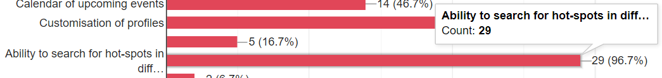

As can be seen above during our stakeholder survey the ability to search and filter through hot-pots and events was a much requested feature. 96.7% of the stakeholders answered that they would want this as a feature on the website.

**Subcomponent 2**

Allow registered members to customise their profile pages/visible information

**Description**

Allow users to customize their profile pages and edit there personal information. Users should be able to edit there personal details such as name, age, location and personal description. They should also be able to change the colours on the profile as well as being able to upload pictures of places they have been.

I will implement this feature by having colours and backgrounds that users can choose from for their profiles. All of their details will also be able to be edited from the profile pave itself.

**Priority**

If all goes to plan the website should have this feature however it is not critical.

**Justification**

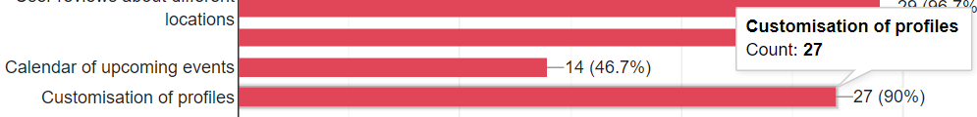

When asked what features they would like to see on the website 90% of the stakeholders said that they would want customizable profiles. While this is a very high percentage I have given this feature a lower priority as the website would still be functional without it.

**Subcomponent 3**

Include recommendations across all categories (e.g. potentially relevant alternatives) based on search criteria if no matching results are returned

**Description**

This feature would recommend alternatives to the user if there search results were to return nothing. An example might if the user searches for bars in Italy but there are no results it would instead recommend some restaurants.

**Priority**

I have set the priority for this task to be low I believe this is something that will be added only if there is extra time for it.

**Justification**

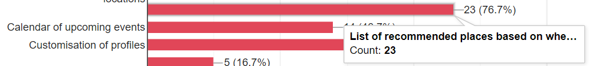

Only 76% of the stakeholders said they would like this feature to be implemented into the website. While this is still a good majority it has placed this feature further down the list in terms of priority. Additionally I believe that this feature to be an extra rather then something the site needs to be functional.

## Lee Haley (W16014111)

### Introduction

For this project we are going to be building a website designed for travellers who want to share their experiences of travelling and also connecting to these people through forums. For this project we have 5 subcomponents within the team and for my subcomponent is the discussion board/forum. Below is a description of my subcomponent:

|  |  |
| --- | --- |
| Subsystem 4 | Discussion board/forum  A web-based interactive system which:   1. Must only allow organising committee members to create and view threads (topics) for discussion. 2. Must allow only registered members to view and post messages. 3. Must allow responses by registered members (giving username and date of post). 4. Should allow reporting of inappropriate messages to admin. 5. Could ensure that inappropriate language is subject to automatic moderation. |

So here we have 3 must subsections, one should and one could. I will obviously be aiming to complete all of them to an exceptional level. These are just guidelines so that the first 3 objectives have to be done and they are a bit difficult but will be done. The second last one will be challenging but it should be included within my subsection. Then the last objective is of great difficulty and if included will create a perfect discussion board for what I am wanting to create. All of these goals even though the latter are difficult they will be included within the discussion board so that we can create a great website. This also helps me have a guideline for prioritising the work that I will need to be doing.

### Stakeholder input

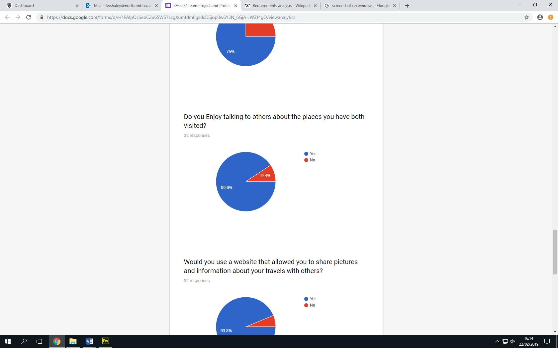So for our team to produce this idea for our project we needed some input from stakeholders. So to get these results we ran a questionnaire and got some results back to see what areas we could improve on. So for my subsection which is the discussion board we needed to know whether it would be a good idea or not and these were the results we got back:

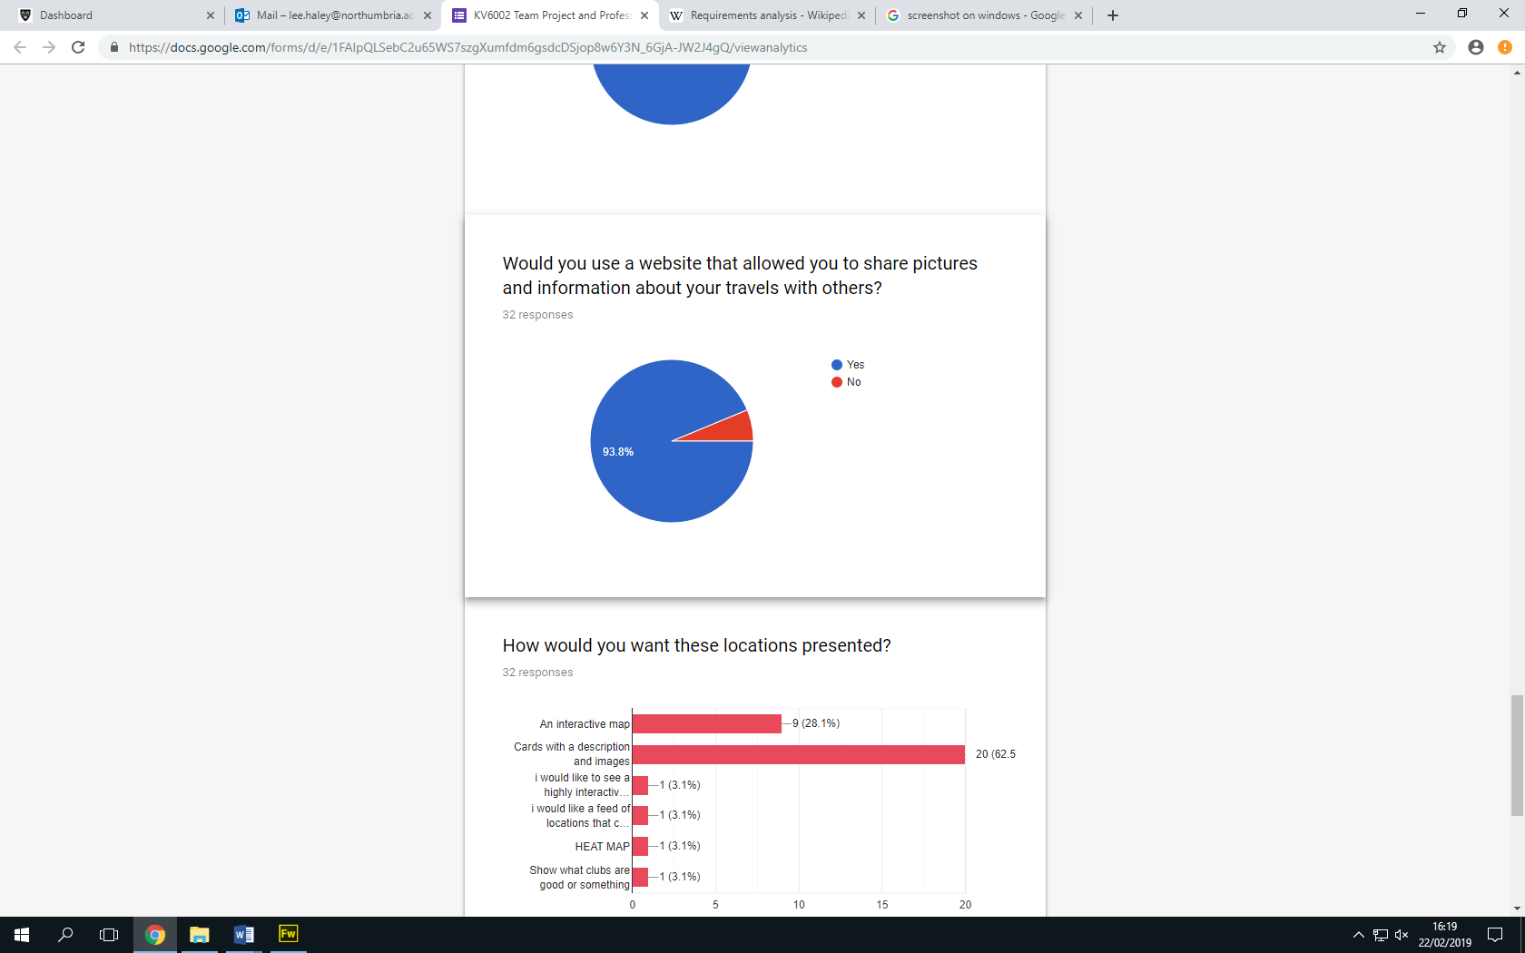

So these are the results we got back from stakeholders regarding my specific subsection. So we can see that they want a website where they can share and talk about their travels, they also like recommending places for travelling. So with these results they show that there is a gap in the market for a website we are trying to create and people want to have a social media specifically for their travelling and they want to share their experiences. So with this we decided to do the website and everyone’s subsection with the results we got regarding my subsection we decided to put in the discussion board as we thought it would be vital for our project.

## Predicted look for system

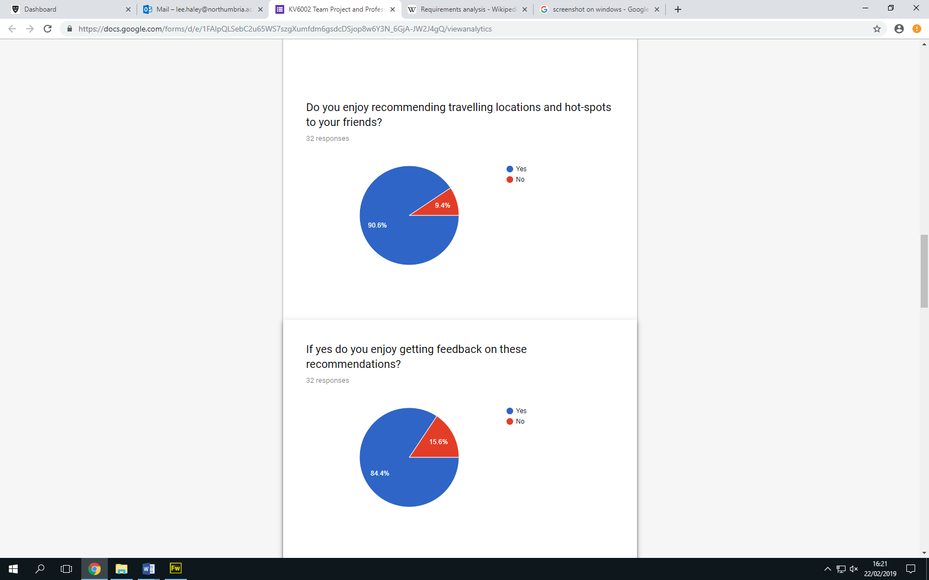

For my discussion forum I need it to have all of the subcomponents that I mentioned earlier. So with this when I was doing the market research earlier in the task for our group task I researched TripAdvisor and looked at their discussion boards and saw how the look and feel of them were like they divide them up into continents then pick a country and choose a topic that has been created or create a new topic for a specific country. For my discussion board I will have a list of countries then people can see existing forums or create a new but with mine they will have to be logged in a organising member to even create one of these forums and if they are not a member of the site then they will need to be to choose a forum. My forums will also have a zero tolerance on offensive language.

## References

Birmingham, P. and Wilkinson, D., 2003. *Using research instruments: A guide for researchers*. Routledge.

Travello, 2018, https://www.travelloapp.com/.

TripAdvisor 2019, <https://www.tripadvisor.co.uk/?fid=f24b97fb-4035-4f80-a518-da7e4f94a6c0>.

Zeng, B. and Gerritsen, R., 2014. What do we know about social media in tourism? A review. *Tourism management perspectives*, *10*, pp.27-36.

## Aows Rashad (W16024005)

### Introduction

|  |  |
| --- | --- |
| Subsystem 2 | Travel Rating and Recommendation  A web-based interactive system which:   1. Must allow all registered members to suggest/recommend travel spots (i.e. create, edit, delete travel suggestions based on text graphical representations). 2. Must enable other registered members to rate a suggested travel spot. 3. Must enable other registered members to leave reviews (i.e. comment on) a suggested spot. 4. Should allow an organising committee member to suspend, edit or delete a suggest spot or review. 5. Could provide a registered member with a list of system generated recommendations based on their habits or the similarities of other locations. |

The travel rating and recommendation (TRR) system must provide registered users the choice of the **creation, editing and deletion** of travel spots. They will be prompted with a form which will include inputs for them to fill in, these inputs will be.

* The title of the destination (i.e. family holiday, party destinations and more) which can be incorporated as a simple text box.
* The exact location of the spot which can be incorporated either as an interactive map in which they place the marker of the location or a text box where they would write the address of the location and a drop down menu would give them the closest match to what they wrote.
* A description of the location such as why they felt that this location is worth visiting and what amenities it included, this will also be incorporated as a text box as it is the most suitable.
* Lastly the user can submit a photo of the location that they recommended which I think is very important as it provides other users with a good visual representation therefore the rating of the locations will be more accurate.

The TRR system must provide registered members the choice of rating and reviewing the submitted travel locations. This will be incorporated in to the system as a comment section below the submission. The inputs this component will include.

* A title of the submitted review used to summarize the description of the review, this can be capped to a maximum of 40 characters to prevent over spill. This will be incorporated as a static text box at the top of the element.
* A detailed review of the location used to give other users insight of why the reviewer has come to their conclusion. This will also be incorporated as a text box however it will be much wider and longer and will be capped to 200 characters to allow for more detailed description. This input will be optional as not everyone will want to interoperate exactly why they left the review.
* Media submission, the reviewer can submit a photo as evidence to further backup their review. This will also be optional as not everyone will have a photo to submit.
* Lastly the user can leave a score to further summarize their review, this will be incorporated as a star based rating system where they can choose out of 5 stars. This function is quite important as it could be used to create a recommender system later on which will be based on user reviews.

The TRR system should allow administrators the ability to suspend, edit or delete submitted suggested locations or reviews, the reason for using this functionality is to discourage users from abusing the system by posting fake locations or leaving inappropriate reviews rather than constructive ones.

* To complete this functionality the application will determine what type of user is logged in; if it has determined that an admin account has logged in, extra buttons such as suspend, edit or delete will appear on each submission and review.

The TRR system could provide registered users with a list of recommendations based on their habits with other users or the similarity of other locations. This is a widely popular tool used by ecommerce websites to increase the sales of their items but it can also be used to increase the amount of time users spend on the website. Including this function will require to do a few things to determine what the most suitable method of extrapolation is.

* Data collection – creating a recommender system will require me to gather user data which will be used to determine their preferences. There are two ways of collecting user data. Implicit data collection which is logging the user actions on the website then determining their behaviour based on their actions (I.e. visiting the same post more than once, leaving a positive review on a specific post). Explicit data collection which is taking the users star rating (from 1 to 5) to determine what they like. This will be the method that we will use as we have already incorporated a rating system in previous function.
* Data filtering – the next step is to filter through the data to make a prediction on what the user will like, the first method is passive filtering which simply put means using the average rating of each location to predict the next one, drawback to this system is that users will only be shown top rated submissions and not necessarily user specific. The second method active filtering is a bit more advanced as it uses the patterns of a user and compares it different users for similarity then makes a prediction. The method I will use to filter the data will be a collection of both methods, I will retrieve the average scores the locations however I will use the scores submitted by the users to determine their preference then I will work out the similarity between each users using K nearest neighbour algorithm which will use the Euclidian distance metric to calculate how far apart one rating is from another one thus giving me a similarity score.

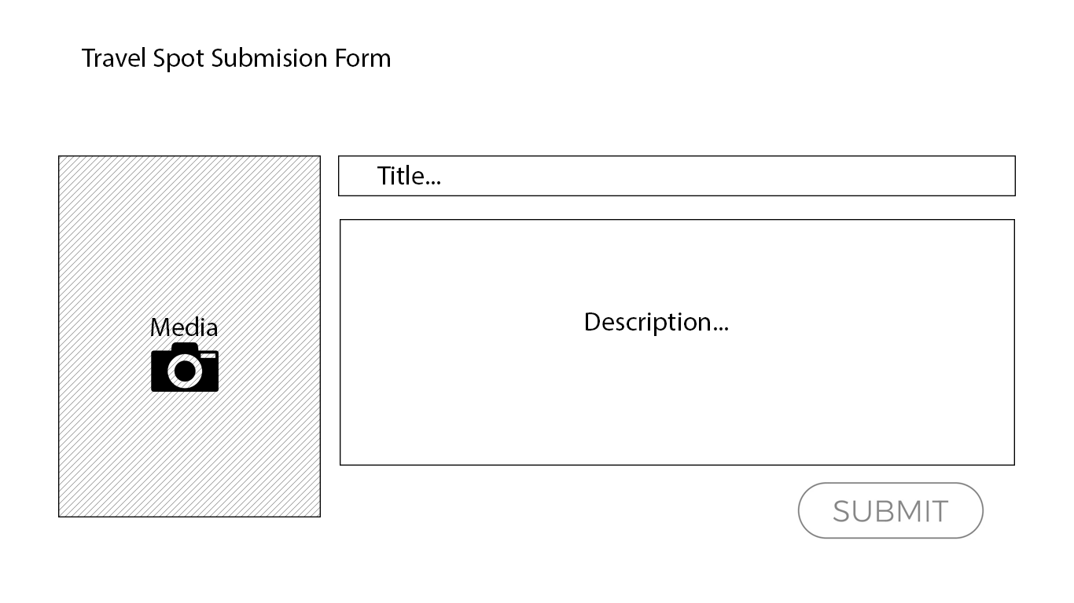

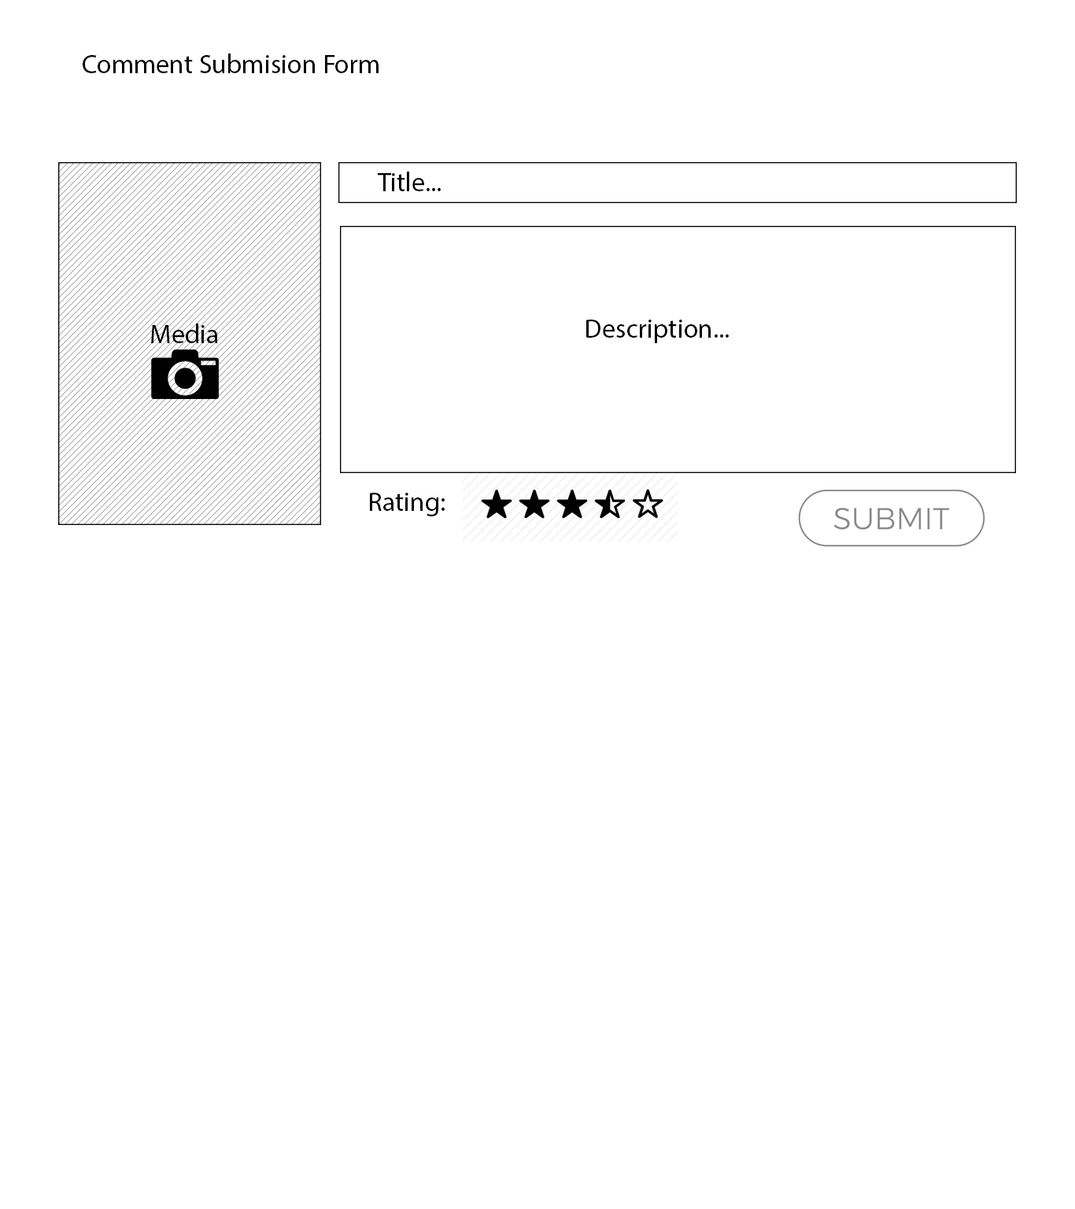

## Umar Shaban (W16015928)

### Requirements Capture Plan

To be able to develop my subcomponent to the best possible standard, I will need to obtain a range of different requirements that will provide me with enough information on developing a subcomponent of the web system that allows registered users to create, edit, delete and archive events. Users can create events which can include reviews where a user can publish their viewpoints and opinions with other users in which they can offer recommendations. User can delete their currents events whenever they like, users can edit current events if they wish to modify their reviews because of a change of opinion or they may have made a mistake e.g. spelling and grammar errors etc. This document will walk through the different types of methods that will be used to help obtain useful requirements for creating the system.

#### Questionnaire

One document that I will use to help gain requirements is a questionnaire document, by using a questionnaire document I can find out the views and opinions from users about our system, they could be asked to rank from 1 to 10 (1 being the least and 10 being the highest) on how interested they are in our product and how likely they are to visit our website. Any users who confirm they have a definite interest in using our product may be asked about what their expectations are and what features they would like to see that are not currently within the system. For example, “Would you like the events page to display a map showing the reviewed locations” or “Would you like to see feedback only displayed in text form”. Whilst creating this document it will be important to keep certain things in mind in order to create an effective questionnaire. One aspect that will be important is to keep the questionnaire as short as possible or to at least make it possible to complete the questionnaire in the shortest amount of time. By doing this it will be beneficial towards people who are completing the questionnaire as they will most likely complete it with satisfaction and with honesty (1). If the questionnaire was created in a manner in which there were far too many questions than necessary or if the reader felt it was hugely time consuming, this will bring some negative impacts such as the reader feeling bored and/or frustrated with the document in which they may partially complete the document or may provide answers that are not genuine just to speed up the process.

Furthermore, another aspect of the questionnaire that is equally important is the overall quality of the questions. Whilst creating this document it will be important to take our time and to create a series of high quality questions that not only benefits the reader but will also benefit the group and our system. By asking questions of high quality and is relevant to our project will bring its fair share of advantages as we will be able to extract useful feedback and opinions from our users which will help in the long term when developing my “create an event” webpage as I will be informed of what our target audience would like to see and their expectations (Requirements Techniques, 2018). If the questions are poorly designed and are not relevant to the specified system/sub component then this will simply provide poor and useless information which will not give me a better idea on how to effectively layout the subcomponent. It will also frustrate our target audience as they will feel as if they are wasting their time if the questionnaire is not up to a high standard and if their expectations have not been met with satisfaction.

#### Existing systems

Analysing existing systems is great method to gain new requirements for a system as by observing current systems which have similar purposes, this will help me in identifying important and relevant requirements that I can utilise within my own subcomponent of the web system. However, when looking at current systems which may perform similar roles it is important to ensure I must only take ideas from these systems and not to completely replicate functionalities of these web systems as the subcomponent I will be creating for my system will be different compared to systems which are already on the market and the target audience I am appealing to will be different compared to the target audiences of other organisations. Therefore I will need to be careful of the types of requirements I extract from other systems as I want to prevent creating a subcomponent that does not meet or satisfy the expectations of the target audience.

#### Brainstorming Ideas

Another method that will be used to obtain useful requirements for my system will be the concept of brainstorming a range of different ideas. Through the use of brainstorming, this can be a powerful way to develop new ideas for the system and in particular my subcomponent as the entire group can engage with each other and consider all types of scenarios that can possibly occur with this system, group members can consider different ‘what if’ scenarios where we can discuss what might occur if I design the subcomponent in a specific way and what impacts can occur from my decision making (Inflectra, 2018). With brainstorming this can be implemented in a number of ways such as having a face to face discussion with other group members where we can exchange different opinions or I can create a word document where I can write down all of my ideas and also the ideas of my group members where I can review and analyse each idea/viewpoint and decide which ones I should take on board and which ones I should avoid. By encouraging other members to provide me with their viewpoints it will help to broaden my mind to fresh alternatives I may not have considered initially.

In addition, another advantage of brainstorming will allow me to look at my own design from an objective and critical point of view without being influenced by any biases I may have. By allowing myself to think more critically I will be more likely to approach a problem and solve it in a logical and effective way, it will allow me to possibly break my subcomponent down into different sections where I can revaluate my designs and features that I have implemented and to hopefully come to a conclusion on whether I should maintain or remove the ideas that have been brought up (Price K, 2019).

#### Requirements Analysis

#### Current Systems

**Travello**

In terms of the current systems available on the market that are similar to the system I am designing. One example of a system that is similar is an app called ‘Travello’ which is essentially a social network for users who are travellers and can meet up and engage with other travellers. With this app users can:

* Find other travellers who are nearby and can join up with (Travello, 2018)
* Post their photos and travel updates on a social feed, whilst also being able to interact with other users (Travello, 2018).
* Users of the app can join groups of other travellers who share similar interests (Travello, 2018).
* Find travellers who will be in the same location at a specific time (Travello, 2018).
* Find out the best travel deals worldwide (Travello, 2018).
* A global map which contains points of interest, things to do etc. (Travello, 2018)

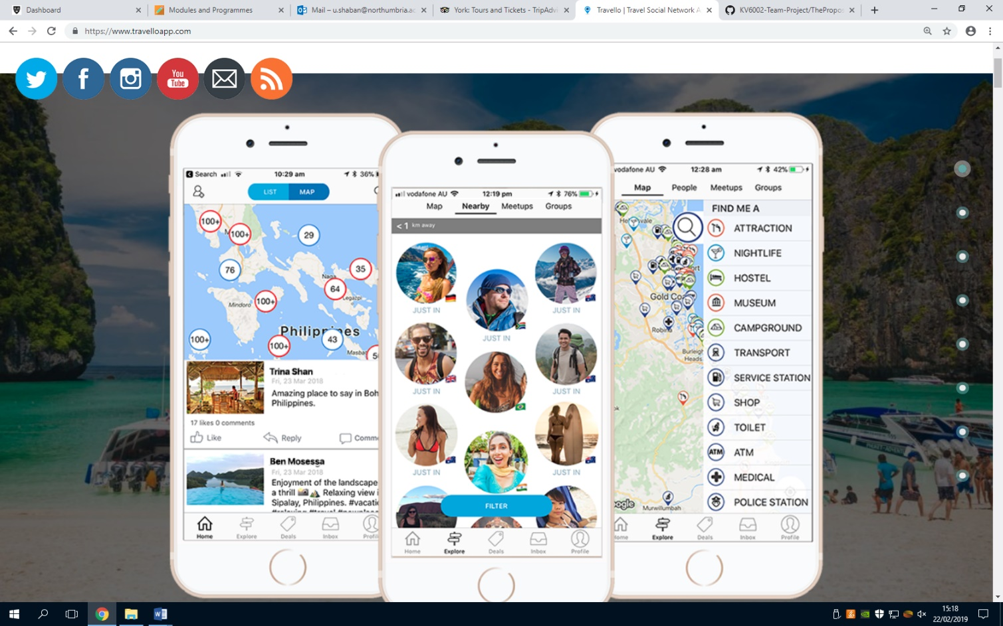

Figure 1: The image above shows the design and user interface of the mobile app.

Based on the design of the app and the features that it contains, this app has an appealing and professional appearance which can attract first time users to install this app on their IOS or Android devices based on first impressions. The user interface of this app looks attractive and of high quality which will persuade users to think this app was developed by experts and not by amateurs, this app has some interesting features that were mentioned earlier which are similar to the features I aim to implement into the system. One of the features of this app that is interesting and similar to the subcomponent I am involved in creating is the “Users of the group can join groups of other travellers who share similar interests“ feature which is something I could potentially implement in my ‘create an event’ subsystem as the purpose of the web-based system is to attract users to register and collaborate with other travellers. This is an intriguing feature I could use as a temple for my event creation component although it will be crucial to make certain changes to this feature to make it uniquely different.

Another interesting feature from this mobile app is the “A global map which contains points of interest, things to do etc.” feature. This is another functionality that I could potentially use within the create an event design where a registered member of the website can create a brand-new event and then possibly include a map which will display the exact destination, what activities can be done in that location etc. there are a range of different things I could include to meet the needs of the target audience. Overall this mobile app which has been created to specifically target users who enjoy travelling has been useful in providing me with new ideas of what to implement in my subcomponent as the purpose and functionalities are similar to my own system. However, it is important to note that one major difference between this app and the system I aim to complete is that the ‘travello’ system is based purely on a mobile app whereas the system I am involved in developing will be an online web-based system and will not be compatible with mobile devices. So as a result, certain elements will be completely different from this mobile app in terms of screen resolution, screen size, user interface, font size, image sizes etc.

**Backpackr**

Another example of an existing system which has a familiar system is a mobile app called ‘Backpackr’ which is an app that allows users to find other travel buddies and connect with other travellers around the world, this app allows users to other travellers who share similar interests, who travel to the same locations, and share photos with friends (Backpackr, 2017). The Backpackr app includes a ‘Backpackr Community’ in which users can submit their opinions about the locations they have visited through online reviews, the app also includes a ‘Common Room’ where users of the app can search for nearby posts or can search for a certain country using keywords or hashtags (Backpackr, 2017).

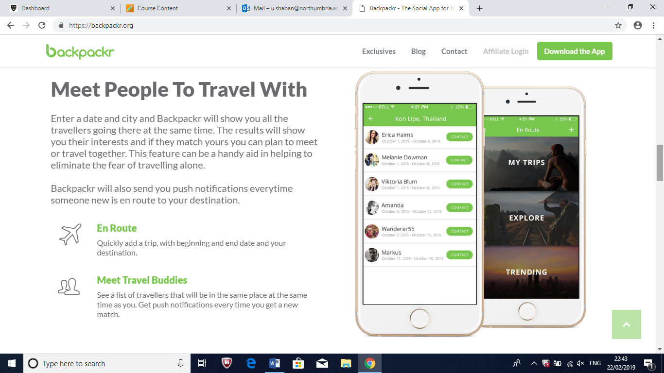

Figure 2: this image shows the designs and the user interface of the app

Just like the previous app I mentioned, this traveller’s app looks to have been designed professionally and to a high standard as the style/theme of the app is consistent and it has a creative display. Just like the previous app this app also shares similar functions with a couple of different features such as being able to post online reviews about visited destinations and that the app allows users to search for nearby posts with keywords/hashtags. This app is also compatible with both IOS and Android so that all users of mobile devices have an opportunity to install this app on their smartphone.

The feature that involves being able to search for nearby posts with keywords or hashtags is an interesting functionality which I may possibly use within my own subcomponent which can help improve the overall quality of the web system as the users of our system will have a variety of functionalities at their disposal. Although I will need to be certain the target audience would be satisfied with this feature if it was implemented or if the target audience will feel it is unnecessary to have this feature in the system, I can find out if users would be interested in this by using questionnaires, interviews etc. Furthermore, another useful feature of this app is users can post online reviews about the locations they have travelled to. This is a feature I intend to use in my subcomponent as I want registered users to be able to provide feedback on their destinations and to share their opinions with other users of the site. I will intend to make different changes to my version of the review system by using a star rating out of 5 or a rating out of 10, the comment box may possibly include a word limit restriction to prevent the text from taking up too much physical space of the webpage etc.

#### Stakeholders

* Project Supervisor
* Members of staff
* Group members
* Consumers
* Users who have an interest in travelling
* Organisations who have developed and provided similar systems (Lagreca, 2018).

#### References

Requirements Techniques. (2018). *Questionnaire*. [online] Available at: https://requirementstechniques.wordpress.com/elicitation/questionnaire/ [Accessed 18 Feb. 2019].

Inflectra.com. (2018). *Requirements Gathering*. [online] Available at: https://www.inflectra.com/ideas/topic/requirements-gathering.aspx [Accessed 18 Feb. 2019].

Price, K. (2019). *The Importance of Brainstorming*. [online] Smallbusiness.chron.com. Available at: https://smallbusiness.chron.com/importance-brainstorming-77488.html [Accessed 19 Feb. 2019].

Travello | Travel Social Network App | Meet Travellers Nearby. (2018). *Travello | The Social Network App For Travellers*. [online] Available at: https://www.travelloapp.com/ [Accessed 19 Feb. 2019].

Backpackr.org. (2017). *Backpackr - The Social App for Travellers | Find a Travel Buddy*. [online] Available at: https://backpackr.org/ [Accessed 20 Feb. 2019].

Lagreca, K. (2018). *How To Identify Stakeholders For Your Website Project*. [online] Npgroup.net. Available at: https://www.npgroup.net/blog/how-to-identify-stakeholders-for-your-website-project/ [Accessed 21 Feb. 2019].

### Requirements Specification List

|  |  |  |  |
| --- | --- | --- | --- |
| Requirement ID | Requirement Description | Functional or non-functional? | Priority |
| 1 | The system must allow registered members to create an event. | Functional | High |
| 2 | The system must allow registered members to edit any current events to be able to modify/update any details about the event. | Functional | High |
| 3 | The system must allow registered members of the system to delete any events. | Functional | High |
| 4 | The system must allow registered members to archive an event of their choosing. | Functional | High |
| 5 | The system must allow all registered members to sign up to any event of their choice. | Functional | High |
| 6 | The system must allow all registered members to cancel their place on an event. | Functional | High |
| 7 | The system must be connected to a database server to store and extract information. | Functional | High |
| 8 | The system must not allow non-registered users to create, edit, delete or archive an event. | Functional | High |
| 9 | The system should allow comments to be made on an event page by certain registered members who have signed up to attend. | Functional | Medium |
| 10 | The system should have a style/theme that is consistent with the other webpages. | Non-functional | High |
| 11 | The system should always be reliable in which registered members can create, edit, delete, and archive events without any errors or other technical issues from occurring. | Non-functional | Medium |
| 12 | The system should have an appropriate font size to help maintain the text as readable as possible for the user. | Non-functional | Medium |
| 13 | The system should be able to achieve a high-speed performance without any issues from occurring which may slow the system. | Non-functional | Medium |
| 14 | The system should to be able to operate on a 24/7 basis | Non-functional | High |
| 15 | The system should have security validations in place to prevent any damage from occurring by malicious hackers. | Non-functional | High |
| 16 | The system could provide a calendar view to display upcoming events. | Functional | Low |
| 17 | The system could have a word limit restriction placed within the comments box to prevent registered users from typing too much information that may take up a huge amount of physical space. | Functional | Low |
| 18 | The system could provide images that are relevant to the locations being reviewed. | Functional | Low |